EREBUS
厄瑞玻斯号

The Story of a Ship
一艘船的故事

michael palin

此处版权和其他声明的翻译 不确定是否需要 因此暂略

For Albert and Rose

And indeed, nothing is easier for a man who has, as the phrasc goes, ‘followed the sea’ with reverence and affection, than to evoke he great spirit of the past upon the lower reaches of the Thames. The tidal current runs to and fro in its unceasing service, crowded with memories of men and ships it had borne to the rest of home, or to the battles of the sea… from the Golden Hind returning with her round flanks full of treasure... to the Erebus and Terror, bound on other conquests - and that never returned.

Joseph Conrad, Heart of Darkness

致Albert和Rose
诚然，对于一个曾怀着敬畏和热爱去“追随大海”的人来说，没有什么比泰晤士河的下游更容易唤起曾经的雄心壮志。潮水不停地来回奔流，满载着关于人类和船只的回忆，承担着背井离乡的思苦，也见证了海上的无情厮杀……从满载财宝并凯旋归来的金鹿号……到壮志未酬却一去不返的厄瑞玻斯号和恐怖号。

Contents
目录
目录暂不翻译 放在全文的最后
303 311

Introduction: Hooker’s Stockings

xi

Prologue: The Survivor

1
1

Made in Wales

5
2

Magnetic North

19
3

Magnetic South

35
4

Far-off Shores

49
5

‘Our Southern Home’

73
6

‘Farther south than any

(
Known) human being has been’

89
7

Dancing with the Captains

113
8

‘Pilgrims of the Ocean’

121
9

‘Such a wretched place as

this you never saw’

149
10

‘Three years from Gillingham’

163
11

Homeward Bound

177
12

‘So little now remains to be done’

187
13

North by North-west

211
14

No Signal

235
15

The Truth

249
16

Life and Death

263
17

The Inuit Story

277
18

Resurrection

291
Epilogue: Back in the
Northwest Passage

Appendix: Timeline

Acknowledgements

Picture Acknowledgements

315
321
Index 323
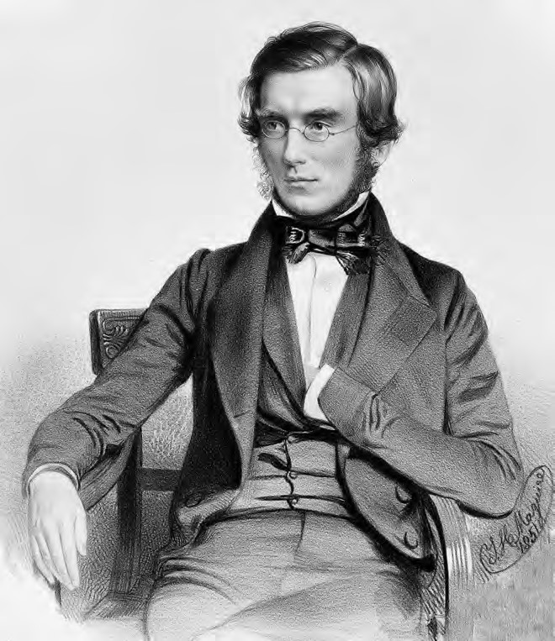
At the age of just twenty-two, Joseph Dalton Hooker joined the crew of
HMS
Erebus
as assistant surgeon. He went on to become one of the
greatest botanists of the nineteenth century.

年仅22岁的Joseph Dalton Hooker以外科助理医师的身份加入了皇家海军的厄瑞玻斯号。他后来成为十九世纪最伟大的植物学家之一。
INTRODUCTION
引言

HOOKER’S STOCKINGS

胡克的袜子
I’ve always been fascinated by sea stories. I discovered C.S. Forester’s Horatio Hornblower novels when I was eleven or twelve, and scoured Sheffield city libraries for any I might have missed. For harder stuff, I moved on to The Cruel Sea by Nicholas Monsarrat – one of the most powerful books of my childhood, even though I was only allowed to read the ‘Cadet’ edition, with all the sex removed. In the 1950s there was a spate of films about the Navy and war: The Sea Shall Not Have Them, Above Us the Waves, Cockleshell Heroes. They were stories of heroism, pluck and survival against all the odds. Unless you were in the engine room, of course.
我曾一度痴迷于航海故事。在我十一、二岁的时候，我就看过C.S. Forester的《霍恩布洛尔船长》的系列小说作品，并为此翻遍了谢菲尔德市的图书馆。后来，我又进一步拜读了Nicholas Monsarrat的《沧海无情》——这是童年时代对我影响最大的书之一，尽管我只被允许读“军校生版”，也就是没有色情描述的版本。在20世纪50年代，涌现了大量和海军和战争有关的电影：《海上救援纪实》，《威震大西洋》，《轻舟英雄》。这都是些和英雄主义、勇气和努力求生有关的故事。当然，如果你真的在当时的船舱里可能就是另一番景象了。
As luck would have it, much later in life I ended up spending a lot of time on ships, usually far from home, with only a BBC camera crew and one of Patrick O’Brian’s novels for company. I found myself, at different times, on an Italian cruise ship, frantically thumbing through Get By in Arabic as we approached the Egyptian coast, and in the Persian Gulf, dealing with an attack of diarrhoea on a boat whose only toilet facility was a barrel slung over the stern. I’ve been white-water rafting below the Victoria Falls, and marlin-fishing (though not catching) on the Gulf Stream – what Hemingway called ‘the great blue river’. I’ve been driven straight at a canyon wall by a jet boat in New Zealand, and have swabbed the decks of a Yugoslav freighter on the Bay of Bengal. None of this has put me off. There’s something about the contact between boat and water that I find very natural and very comforting. After all, we emerged from the sea and, as President Kennedy once said, ‘we have salt in our blood, in our sweat, in our tears. We are tied to the ocean. And when we go back to the sea . . . we are going back to whence we came’.
幸运的是，后来我在船上度过了很多时光，在那些日子里我常常远离家乡，只有英国广播公司(BBC)的摄影人员和Patrick O’Brian的小说相伴。我曾在一艘驶往埃及海岸的意大利游船上，疯狂翻阅《阿拉伯语入门》，也曾在一艘波斯湾的船上处理腹泻问题——这艘船上唯一的厕所是一个挂在船尾的桶。我曾在维多利亚瀑布下泛舟漂流，也曾在墨西哥湾流——也就是海明威提及的“伟大的蓝河”——上垂钓(虽然最终没有钓到鱼)。我曾在新西兰乘坐一艘喷气式推进艇在峡谷间横冲直撞，也曾在孟加拉湾擦洗一艘南斯拉夫货轮的甲板。这一切都没能阻挡我，因为船和水的接触能让我觉得很自然，很舒服。毕竟，我们起源于海洋，正如肯尼迪总统曾经说过的那样，“我们的血液里有盐，我们的汗水里有盐，我们的眼泪里有盐。海洋束缚着我们。而当我们回到大海时……我们只是回到曾经我们来的地方。”

In 2013 I was asked to give a talk at the Athenaeum Club in London. The brief was to choose a member of the club, dead or alive, and tell their story in an hour. I chose Joseph Hooker, who ran the Royal Botanic Gardens at Kew for much of the nineteenth century. I had been filming in Brazil and heard stories of how he had pursued a policy of ‘botanical imperialism’, encouraging plant-hunters to bring exotic, and commercially exploitable, specimens back to London. Hooker acquired rubber-tree seeds from the Amazon, germinated them at Kew and exported the young shoots to Britain’s Far Eastern colonies. Within two or three decades the Brazilian rubber industry was dead, and the British rubber industry was flourishing.
2013年，我曾受邀在伦敦的雅典娜俱乐部(Athenaeum Club)发表演讲。这件事简单来说，就是选择一名俱乐部的成员并在一个小时内讲述他们的故事，无论这位成员是否还在世。而我选择了约瑟夫·胡克(Joseph Hooker)，他在19世纪的大部分时间里负责管理英国皇家植物园。我当时正在巴西拍摄，听说他奉行“植物帝国主义”的政策，鼓励植物猎人将外来的、可用于商业开发的标本带回伦敦。胡克将从亚马逊获得橡胶树的种子，在英国邱园里成功培育发芽，并把幼芽出口到英国远东殖民地。二、三十年后，巴西的橡胶工业灭亡，而英国的橡胶工业得到了蓬勃的发展。
I didn’t get far into my research before I stumbled across an aspect of Hooker’s life that was something of a revelation. In 1839, at the unripe age of twenty-two, the bearded and bespectacled gentleman that I knew from faded Victorian photographs had been taken on as assistant surgeon and botanist on a four-year Royal Naval expedition to the Antarctic. The ship that took him to the unexplored ends of the earth was called HMS Erebus. The more I researched the journey, the more astonished I became that I had previously known so little about it. For a sailing ship to have spent eighteen months at the furthest end of the earth, to have survived the treacheries of weather and icebergs, and to have returned to tell the tale was the sort of extraordinary achievement that one would assume we would still be celebrating. It was an epic success for HMS Erebus.
还没怎么深入研究，我就出乎意料地发现了胡克不为人知的一面。1839年，青涩的胡克才刚刚22岁，这位留着胡子戴着眼镜的绅士被任命为外科助理医师和植物学家助理，开始了为期四年的皇家海军南极考察。而他乘坐着的用来探索未知之地的那艘船叫厄瑞玻斯号。我对这段旅程研究得越多，就越惊讶于自己以前居然对这件事所知甚少。一艘在地球最遥远的地方航行了十八个月的帆船，最终在恶劣的天气和冰山中幸存了下来，这是一个非凡的成就，值得我们为此进行回顾和庆祝。这是属于厄瑞玻斯号的史诗赞歌。
Pride, however, came before a fall. In 1846 this same ship, along with her sister ship Terror and 129 men, vanished off the face of the earth whilst trying to find a way through the Northwest Passage. It was the greatest single loss of life in the history of British polar exploration.
然而，骄者必败。1846年，这艘船，连同她的姐妹船恐怖号和129人号，在试图找到通过西北航道的方法时从地球表面消失。这是英国极地探险史上人员损伤最大的一次。
I wrote and delivered my talk on Hooker, but I couldn’t get the adventures of Erebus out of my mind. They were still lurking there in the summer of 2014, when I spent ten nights at the 02 Arena in Greenwich with a group of fellow geriatrics, including John Cleese, Terry Jones, Eric Idle and Terry Gilliam, but sadly not Graham Chapman, in a show called Monty Python Live – One Down Five to Go. These were extraordinary shows in front of extraordinary audiences, but after I had sold the last dead parrot and sung the last lumberjack song, I was left with a profound sense of anticlimax. How do you follow something like that? One thing was for sure: I couldn’t go over the same ground again. Whatever I did next, it would have to be something completely different.
我写了一篇关于胡克的文章，也发表了我的看法，但埃里伯斯号的冒险经历却一直在我的脑海里挥之不去，即使是在2014年的夏天，当时的我花费了十天在格林威治的02号舞台和一群病怏怏的老头子——包括John Cleese，Terry Jones，Eric Idle和Terry Gilliam，但遗憾的是Graham Chapman没来——举办了一个叫《巨蟒剧团——干掉了一个，还剩下五个》的表演。这是一场非凡的演出，面对着非凡的观众，但当我卖掉最后一只死掉的鹦鹉，唱完最后一首伐木工人的歌后，我感到一阵失落。接下来要做什么呢？有一件事是肯定的:我不能再走同一条路了。无论我接下来做什么，都必须是完全不同的东西。
Two weeks later, I had my answer. On the evening news on 9 September I saw an item that stopped me in my tracks. At a press conference in Ottawa, the Prime Minister of Canada announced to the world that a Canadian underwater archaeology team had discovered what they believed to be HMS Erebus, lost for almost 170 years, on the seabed somewhere in the Arctic. Her hull was virtually intact, its contents preserved by the ice. From the moment I heard that, I knew there was a story to be told. Not just a story of life and death, but a story of life, death and a sort of resurrection.
两周后，我得到了答案。在9月9日的晚间新闻中，我看到了一篇报道，让我直接愣在了那里。在渥太华举行的新闻发布会上，加拿大总理向全世界宣布，一支加拿大水下考古队在北极某处的海床上发现了他们认为是厄瑞玻斯号的沉船，这艘沉船消失了近170年。她的船体几乎完好无损，里面的东西也被冰冻保存着。从我听到那一刻起，我就知道有一个故事需要得到阐述。这不仅仅是一个关于生与死的故事，而是一个关于生、死和亡者归来的故事。
What really happened to the Erebus? What was she like? What did she achieve? How did she survive so much, only to disappear so mysteriously?
厄瑞玻斯号到底怎么了？她的外表是什么样的？她取得了什么成就？她是怎样幸存下来，却又神秘地消失的呢？
I’m not a naval historian, but I have a sense of history. I’m not a seafarer, but I’m drawn to the sea. With only the light of my own enthusiasm to guide me, I wondered where on earth I should start such an adventure. An obvious candidate was the institution that had been the prime mover of so many Arctic and Antarctic expeditions from the 1830s onwards. And one that I knew something about, having for three years been its President.
我不是海军历史学家，但我对历史很感兴趣。我不是海员，但我被大海深深地吸引着。只有我的热情在指引着我，而对这段冒险我也不知道该从何讲起。一个显而易见的起点是某家机构，它促成了19世纪30年代以来许多北极和南极探险。我对这家机构有所了解，因为我在那担任了三年的会长。
So I headed to the Royal Geographical Society in Kensington and put to the Head of Enterprises and Resources, Alasdair MacLeod, the nature of my obsession and the presumption of my task. Any leads on HMS Erebus?
因此，我前往位于肯辛顿的皇家地理学会(Royal Geographical Society)，向企业与资源部门的负责人Alasdair MacLeod提出了我的困扰和设想。厄瑞玻斯号有什么新发现吗?
He furrowed his brow and thought for a bit: ‘Erebus . . . hmm . . . Erebus?’ Then his eyes lit up. ‘Yes,’ he said triumphantly, ‘yes, of course! We’ve got Hooker’s stockings.’
他皱着眉头思索了片刻：“厄瑞玻斯号……嗯……厄瑞玻斯号?”然后他眼睛一亮。“是的，”他得意地说，“是的，当然有了!我们找到了胡克的袜子。”
Actually they had quite a bit more, but this was my first dip into the waters of maritime research, and ever since then I’ve regarded Hooker’s stockings as a kind of spiritual talisman. They were nothing special: cream-coloured, knee-length, thickly knitted and rather crusty. But over the last year, as I’ve travelled the world in the company of Erebus, and come close to overwhelming myself with books, letters, plans, drawings, photographs, maps, novels, diaries, captains’ logs and stokers’ journals and everything else about her, I thank Hooker’s stockings for setting me off on this remarkable journey.
事实上，他们还有很多发现，不过这是我第一次涉足海洋研究，因此从那时起，我就把胡克的袜子看作是一种精神护身符。它们没什么特别的:奶油色的，长及膝盖，厚针织的，表面还有点硬。但在过去的一年,因为我跟随着厄瑞玻斯号的足迹周游世界，与此相关的书籍、信件、方案、图画、照片、地图、小说、日记、船长日志和司炉账本，以及其他关于她的一切，这些几乎快把我压垮了。但我还是要感谢胡克的袜子，感谢它把我带到这段非凡的旅程中来。
Michael Palin
London, February 2018

伦敦 2018年2月

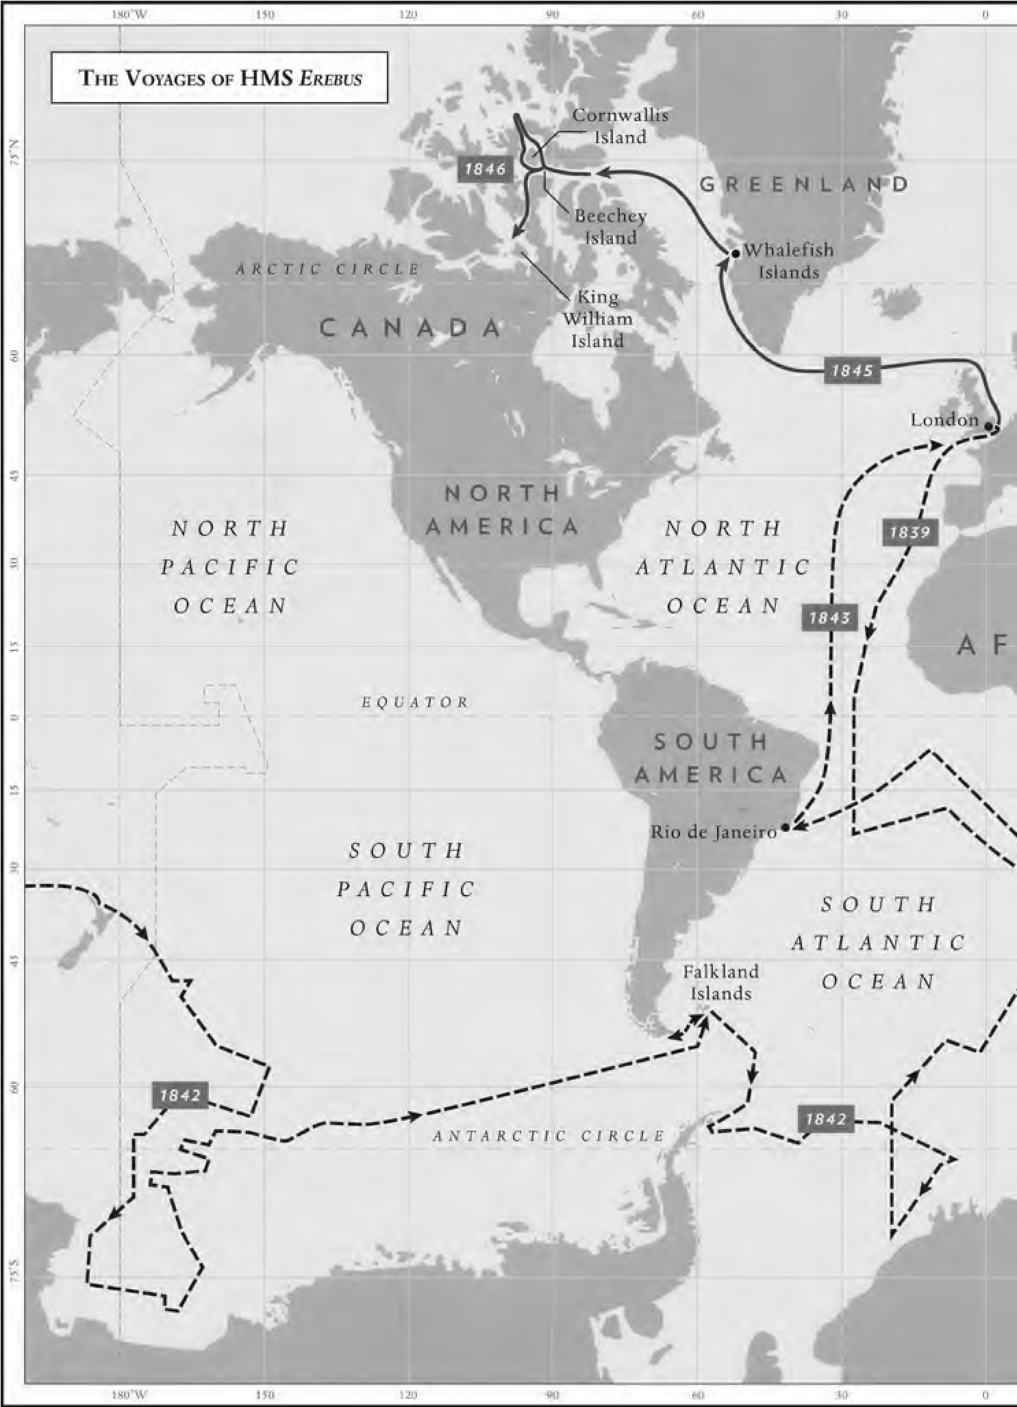
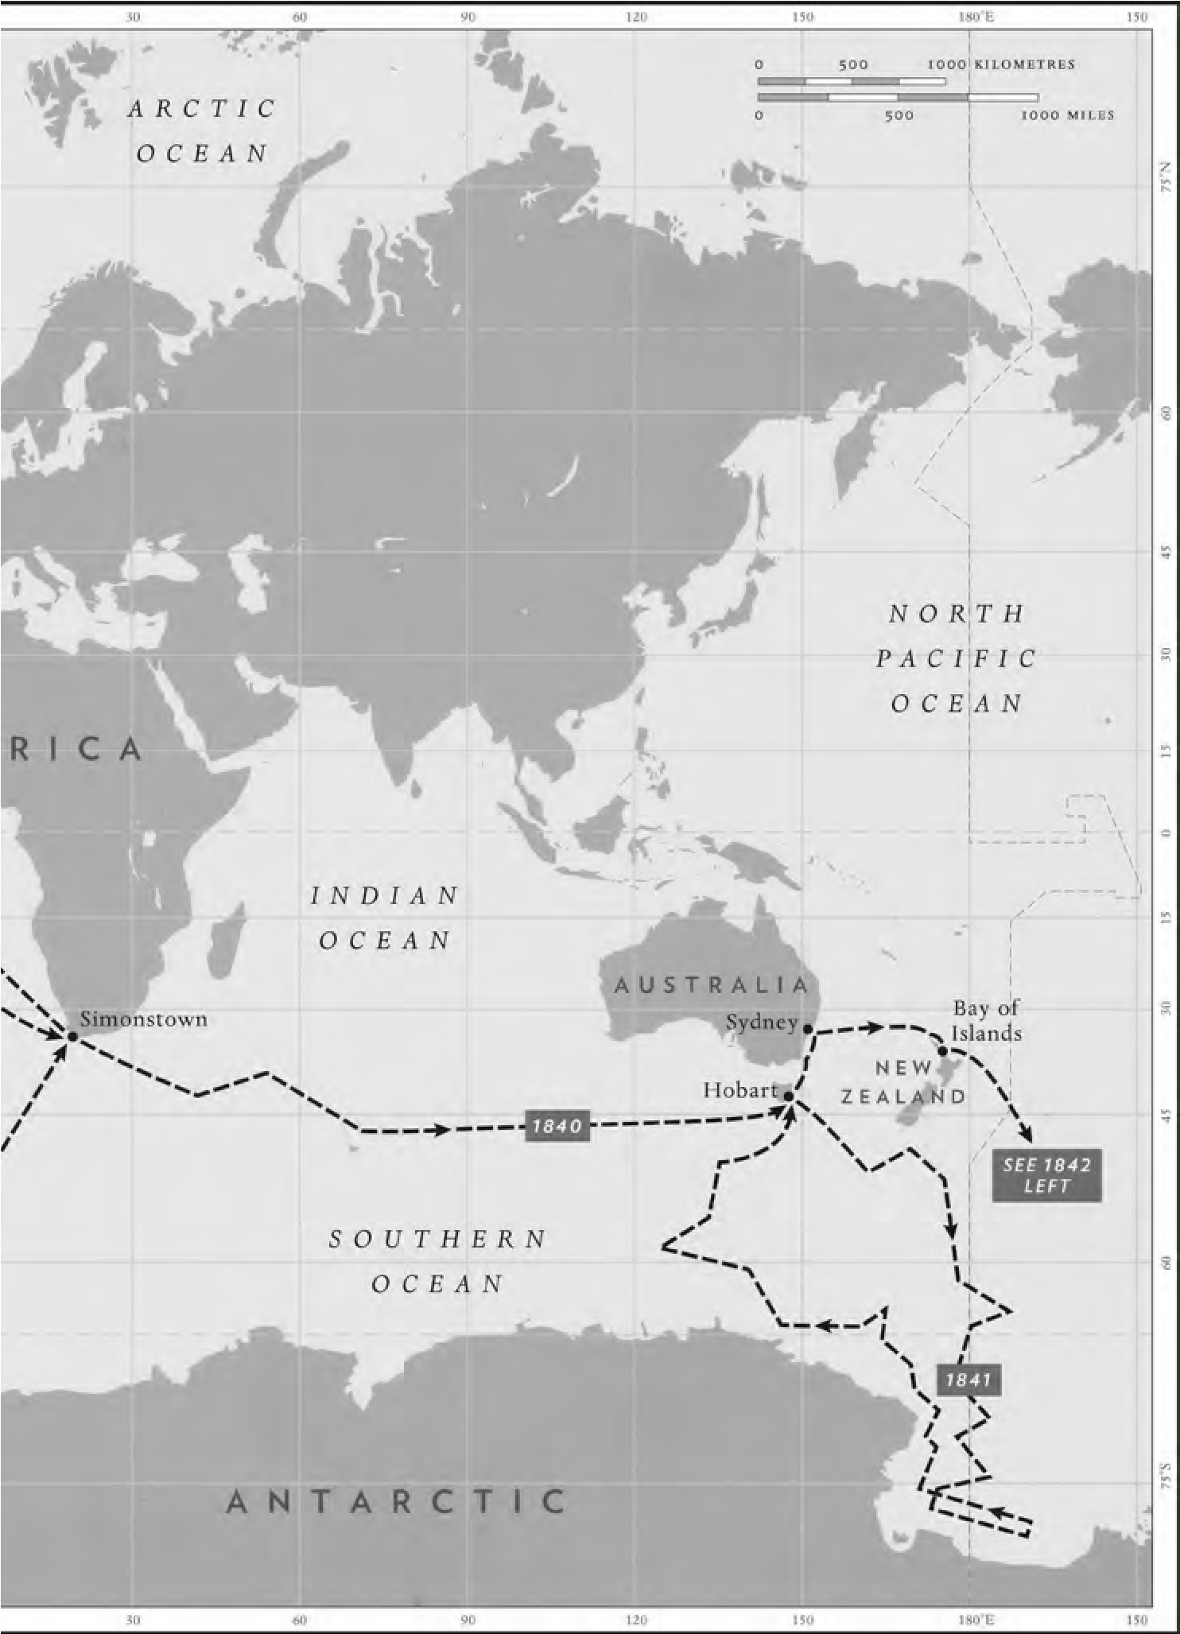
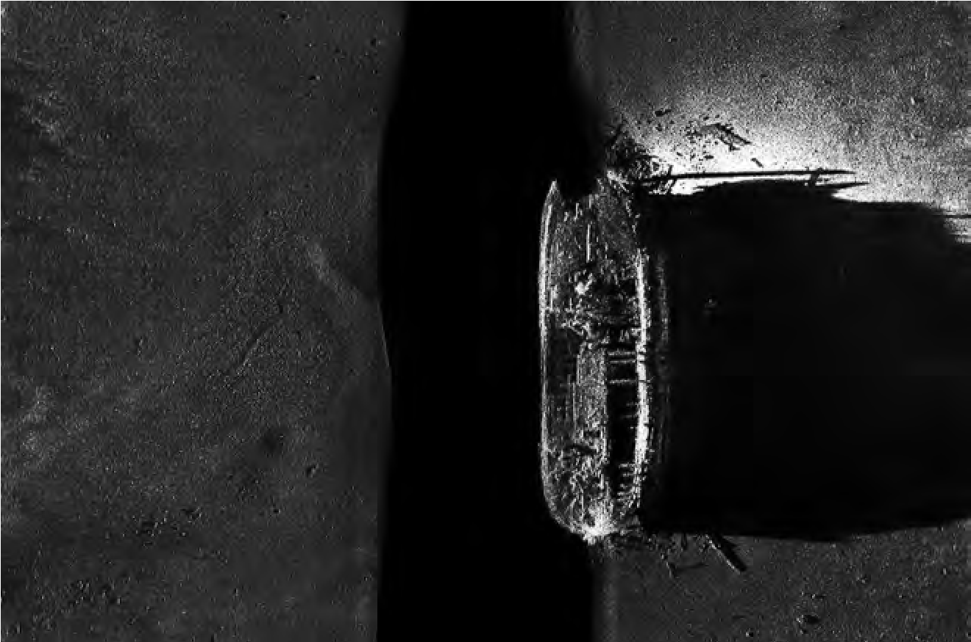
A sonar image, taken in
2014
, of the wreck of
Erebus
. She was discovered
on a shallow part of the seabed – so close to the surface that her masts
would once have peeked out above the waves.

A sonar image, taken in 2014, of the wreck of Erebus. She was discovered on a shallow part of the seabed – so close to the surface that her masts would once have peeked out above the waves.

这是2014年拍摄的一幅厄瑞玻斯号沉船的声纳图。她在海床较浅的地方被人发现的——离海平面很近，以至于她的桅杆都曾暴露在海浪之上。
PROLOGUE
序

THE SURVIVOR

幸存者
Wilmot and Crampton Bay, Nunavut, Canada, 2 September 2014. Near the coast of a bleak, flat, featureless island, one of thousands in the Canadian Arctic, where grey skies, sea and land merge seamlessly together, a small aluminium-hulled boat called the Investigator is moving slowly, carefully, rhythmically across the surface of an ice-blue sea. Towed behind her, just below the water-line, is a slim silver cylinder called a towfish, not much more than 3 feet long. Inside the towfish is an acoustic device that sends out and receives sound waves. The sound waves bounce off the seabed, are returned to the towfish, transmitted up the tow-cable and translated into images of the seabed below.
2014年9月2日，在加拿大的努纳武特区的威尔莫特-克兰普顿湾（Wilmot and Crampton Bay），有一个荒凉、单调并且毫不起眼的岛屿——那是加拿大北极地区的数千座岛屿之一，在这处岛的海岸附近，有一艘名为探索者的铝壳小船正和日常一样缓慢谨慎地在冰蓝色的海面上移动。当时的天空灰蒙蒙的，与海洋和陆地完美地衔接在一起，而在船身后的海平面以下，拖着一个细长的银色圆筒。这叫做“拖鱼”，其长度一般不超过3英尺，内置了一个可以用来发出和接收声波的声学装置。声波从海底反弹，并返回到拖鱼，然后通过拖缆传输并转换显示出海底的图像。
There is not much noise on the Investigator, save for the monotonous drone of her engines. The weather is quiet, the skies clear and a watery sun is shining onto a glassy-calm sea. Everything is muted. Time is passing, but that’s about all.
除了发动机嗡嗡作响外，探索者显得很安静。阳光洒在玻璃般平和的海面上，再搭配着舒适的气候和静谧的天空，仿佛一切都变得寂静无声，仅有时间在此刻慢慢流逝。
Suddenly there’s a commotion: the towfish has narrowly missed hitting a shoal; the attention of everyone on board switches to making sure their expensive sonar device is safe. At that moment Ryan Harris, a marine archaeologist, casting a brief glance at the screen before going to help, sees something other than sand and stones on the seabed. Something that brings him up sharply.
突然一阵骚动打破了这一切：拖鱼刚刚差一点撞上了浅滩；船上的每个人的担心着他们昂贵的声纳设备。就在这时，海洋考古学家Ryan Harris在前去帮忙之前，瞥了一眼屏幕，却看到了除了海底的沙子和石头之外的一些东西，而他也猛然想起了某件事。
On the screen is a dark shape: something solid and unfamiliar, lying right there on the shallow seabed, only 36 feet below him. He shouts out. His colleagues crowd around the computer screen. He points to the shape. They can barely believe what they see: below the Investigator’s silver towfish, indistinct in detail but unmistakably clear in shape, is a wooden hull. It’s broken at the stern as if a bite had been taken out of it, the deck beams are exposed, and all is covered in a woolly coat of underwater vegetation. What they are looking at is a ship. A ship that disappeared off the face of the earth, along with all her crew, 168 years ago. A ship that had one of the most extraordinary lives and deaths in British naval history – and, from this day on, one of the most remarkable resurrections.
屏幕上呈现出一处黑色的形状：像是一个坚实而陌生的东西，就躺在离他只有36英尺的浅海床上。他叫喊着让他的同事们来看电脑屏幕。他指着那处形状。他们都惊讶于他们所看到的：在调查人员的银色拖鱼下面，有一艘木质的船壳，它的细节有些模糊不清，但形状是十分清晰的。它的船尾折断了——看起来像是被咬了一口似的，甲板上的梁也裸露出来，全身都覆盖着一层茸状的海底植物。他们正在看的是一艘船，一艘在168年前就连同所有船员一起离奇失踪的船，一艘在英国海军历史上有着最离奇的生死经历的船——而从这一天起，也是一艘最举世瞩目的亡者归来的船。
She stands proud, so close to the surface that at one time her two tallest masts would have peeked out above the waves. Her hull is solid, apart from some impact-collapse at the stern. Strands of kelp, a large brown algae, cover the outlines of the timberwork like loosefitting bandages. Her three masts have broken off, as has the bowsprit. Pieces of them lie in the nest of debris scattered around her. Amongst the wreckage, half-sunk in the sand, are two of her propellers, eight anchors and a segment of the ship’s wheel. Her three decks have, in some places, fallen in on each other. Many of the main beams that run across the ship appear still to be strong, though the planking above them is mostly stripped away, giving her the appearance – when seen from above – of a half-filleted fish.
她高傲地驻足在那里，距离水面很近，以至于那两根最高的桅杆都曾探出在海平面之上。她的船身很坚固，只是船尾被撞塌了一部分。大片团簇着的海藻和褐藻就像一条条松垮的绷带一样缠绕着整个木结构的船体。她的三根桅杆和船首斜桅都已经断开，由此产生的碎片散落在周围的废墟中。在残骸之中，还有两个半掩埋在沙子里的螺旋桨，八个锚和部分舵轮。三层甲板有很多地方都已经因为破损而叠落在一起，但许多贯穿船体的主梁似乎仍然很坚固，尽管上面的木板大部分也都已经逐渐剥落掉，整个外观——从上面看——给人的感觉就像一条被切片到一半的鱼。
A massive cast-iron windlass stands, undamaged, on the upper deck. Nearby are two copper-alloy Massey pumps. Some skylights and the Preston Patent Illuminators that would have given light to the men below are well preserved.
巨大的铸铁锚机完好无损地矗立在上层甲板上，周围还有两个铜合金质地的Massey牌的泵。部分天窗和Preston发明的照明装置也都被保存得很完整。
The lower deck, where the life of the ship would have gone on, lies exposed in places, still covered in others. Chests where seamen kept their belongings, and on which they sat at meals, can be made out under the accumulation of silt and dead kelp. There are numbers on the deck beams to mark the positions where hammocks would have been slung. Ladderways and hatches giving access to the decks above lie open and ghostly. The galley stove, on which meals would have been prepared, is intact and in position. In the bows, the outlines of the sickbay can be made out.
甲板再往下就是这艘船曾经的生活区了，有的地方已经暴露在外面，有的地方还被其他东西掩盖着。而在这堆积的泥沙和死海带的下面，可以依稀辨认出水手存放物品用的箱子，他们也曾坐在这些箱子上面吃饭。甲板的横梁上记有许多数字，这曾是标记吊床的位置用的。通往甲板的梯子和舱口敞开着，里面透露出些许的阴森恐怖。厨房里用来做饭的炉子依旧保存完好，医务室的轮廓也在船头影影绰绰。
Further aft, portions of the captain’s cabin, the mess room and several of the officers’ cabins are distinguishable through a jumble of collapsed timbers. In one of them is a bed-space, with drawers beneath. The transom – the stern wall of the ship – has suffered most damage, but the captain’s bed cabin next to it is in place, as are lockers and a heater. The orlop deck, the lowest of the three, is least damaged, but also the most difficult to penetrate. A shoe, mustard pots and storage boxes have nevertheless been retrieved. Divers have also recovered a set of willow-pattern plates, the stem of a wine glass, a ship’s bell, a bronze six-pounder cannon, various decorated buttons, a Royal Marines shoulder-belt plate embossed with a crowned lion standing on a crown, and a thick glass medicine bottle with the name ‘Samuel Oxley, London’ embossed on the sides. It originally contained a potion made by Oxley from concentrated essence of Jamaican ginger. He claimed it as a cure for ‘Rheumatism, Indigestion, Windy Complaints, Nervous Headaches and Giddiness, Hypochondria [I love the idea of a medicine for hypochondria], Lowness of Spirits, Anxieties, Tremors, Spasms, Cramp and Palsy’. This all-too-human cure-all remains, for me, one of the most poignant finds on HMS Erebus . A reminder that epic adventures and everyday frailties go hand-in-hand.
而在船尾，透过一堆倒塌的木头，可以看到部分船长舱、餐厅和几个军官舱。其中有一间是卧室，地上散落着一些抽屉。用来围住船尾的尾梁受损是最严重的，而船长的床舱在它旁边，里面还有储物柜和炉子。三层甲板中的最低层是受损最少的，但也是最难穿透的。尽管如此，还是发现了一只鞋、些许芥末罐和几个储物箱。潜水员也找到了一套印有杨柳图案的盘子、一支酒杯的杯脚、一个船钟、一门六磅重的青铜大炮、各种装饰性的纽扣、一个皇家海军陆战队的肩章——上面浮雕着一只站在王冠上并头戴皇冠的狮子，还有一个厚玻璃药瓶——瓶上刻着“Samuel Oxley，伦敦”，里面曾含有一种由Oxley用牙买加姜精制成的药剂。他声称这是一种能治疗风湿病、消化不良、牢骚症、神经性头痛和头晕、疑心病(我喜欢治疗疑心病的药这个主意)、情绪低落、焦虑、颤抖、痉挛、痉挛和瘫痪的药。对我来说，这是厄瑞玻斯号上最令人心酸的发现之一。它提醒着我们，史诗般的冒险中仍难免会有属于平凡生活的脆弱。
For 80 per cent of the year the ice freezes and seals in the ship’s secrets again. But when it melts, people like Ryan – who has made more than 200 dives – along with the rest of the underwater team, will be back in the water looking for many more precious details. My dream would be to get to know Erebus as intimately as they have done. Just once. What I need is Hooker’s wetsuit.
一年中有80%的时间，船上的秘密会被冰封在那里。但当它融化时，像Ryan这样的人——他已经进行了200多次潜水——以及其他水下团队成员，将会回到水里寻找更多珍贵的细节。我的梦想是能像他们那样亲密地了解厄瑞玻斯号。只要一次就好。我希望能找到胡克的潜水服。
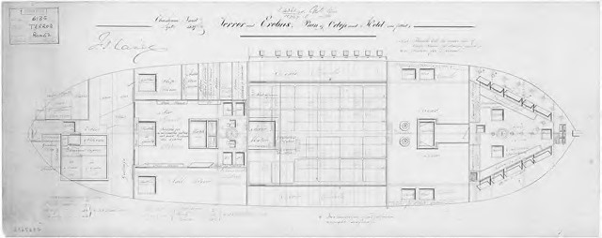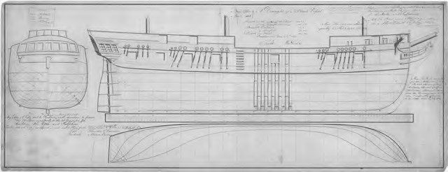
Two contemporary plans showing (above) a typical bomb ship in profile, and (below)
the orlop (or lower) deck and hold of Erebus and her sister ship Terror
两份现代的平面图展示了厄瑞玻斯号及其姐妹船恐怖号所属的典型的炸弹船侧面图示(上图)和下层甲板图示(下图)
chapter 1
第一章

MADE IN WALES

威尔士造船
7 June 1826, Pembroke, Wales: it’s the sixth year of the reign of George IV, eldest son of George III and Queen Charlotte. He is sixtythree, with a quarrelsome marriage, a flauntingly extravagant lifestyle and an interest in architecture and the arts. Robert Jenkinson, 2nd Earl of Liverpool, a Tory, has been Prime Minister since 1812. The Zoological Society of London has just opened its doors. British explorers are out and about, and not just in the Arctic. Alexander Gordon Laing reaches Timbuktu in August, only to be murdered a month later by local tribesmen for refusing to relinquish his Christianity. In north Wales two great engineering achievements are being celebrated, as two of the world’s first suspension bridges, the Menai Bridge and the Conway Bridge, open within a few weeks of each other.
1826年6月7日，在（英国）威尔士地区的彭布罗克市：那年正值乔治四世在位第六年，他是乔治三世和Charlotte王后的长子。已经六十三岁的他对建筑和艺术很感兴趣，生活奢侈的同时也饱受着婚姻的烦恼。而Robert Jenkinson则是当时的第二代利物浦伯爵，属于保守党人，并在1812年起担任英国首相。当时伦敦动物学会才刚刚成立，英国探险家不仅探索北极，也活跃在世界范围内。Alexander Gordon Laing于当年8月份抵达廷巴克图，但一个月后却因拒绝放弃基督教信仰而被当地部落族人谋害。身处北方的威尔士区则在庆祝两项伟大的工程成就，那就是世界上最早的两座吊桥——梅奈桥（the Menai Bridge）和康威桥（the Conway Bridge）——将在几周内相继开放。
At the other end of Wales, in an estuary near the old fortified town of Pembroke, people are gathering on this early June morning for a somewhat smaller celebration. Cheered on by a crowd of engineers, carpenters, blacksmiths, clerks and their families, the stout, broadhulled warship they have been building for the past two years slides, stern first, down the slipway at Pembroke Dockyard. The cheers rise to a roar as she strikes the waters of Milford Haven. She bounces, bobs and shakes herself like a newborn waterfowl. Her name is Erebus.

在威尔士的另一端，古老的要塞城镇彭布罗克附近的河口，人们在6月初的一个早晨聚集于此，举行了一个规模较小的庆祝活动。他们在过去两年里一直在建造一艘质地坚固、体型宽阔的战舰，而在一群工程师、木匠、铁匠、办事员和他们亲友的欢呼雀跃中，这艘战舰从彭布罗克造船厂(Pembroke Dockyard)沿着下水滑道船尾朝下地滑入水中。当她撞击到米尔福德港水域时，欢呼声转变为了咆哮。她像一只新生的水鸟一样在那弹起、回落、起伏、摇摆，她的名字叫厄瑞玻斯号。

It wasn’t a cheerful name, but then she wasn’t built to cheer; she was built to intimidate, and her name had been chosen quite deliberately. In classical mythology Erebus, the son of Chaos, was generally taken to refer to the dark heart of the Underworld, a place associated with dislocation and destruction. To evoke Erebus was to warn your adversaries that here was a bringer of havoc, a fearsome conveyor of hell-fire. Commissioned in 1823, HMS Erebus was the last but one of a type of warship known as bomb vessels, or sometimes just ‘bombs’. They were developed, first by the French, and later the English, at the end of the seventeenth century, to carry mortars that could fling shells high over coastal defences, doing maximum damage without an armed landing having to be risked. Of the other ships in her class, two were named after volcanoes – Hecla and Aetna – and the others after various permutations of wrath and devastation: Infernal, Fury, Meteor, Sulphur and Thunder. Though they never achieved the heroic status of the fighting warships, their last action, the siege of Fort McHenry in Baltimore Harbour in the War of 1812, came to be immortalised in the American national anthem, ‘The Star Spangled Banner’: ‘the rockets’ red glare, the bombs bursting in air’ refers to the fire from British bomb ships.
这不是一个振奋人心的名字，而她也并非为此而被建造；她的出生是为了带来震慑，她的名字也是有意为之。在古典神话中，地狱被认为是充满混乱和破坏的地方，而混沌之子厄瑞玻斯通常被认为是地狱的黑暗之心。引用厄瑞玻斯作为名字就是在警告你的敌人，这艘船将带来一场浩劫，引来地狱的无边恶火。厄瑞玻斯号从1823年开始服役，是最后一艘被称为“炸弹船”的军舰，有时也被称为“炸弹”。这类船是由法国人发明的，后来在17世纪末的时候由英国人改进，装载了迫击炮，使得炮弹可以通过高抛越过海岸防御，无需冒险进行武装登陆就能造成极大的破坏力。和她同级别的船只中，有两艘是以火山命名的——也就是赫克拉号（Hecla）和埃特纳号（Aetna），而其他船只的命名则是充斥着各种愤怒和毁灭的意味：地狱号（Infernal）、狂怒者（Fury）、流星号（Meteor）、硫磺之火（Sulphur）和雷霆号（Thunder）。虽然他们还算不上战斗军舰中翘楚，但他们的最后作战——发生在1812年的巴尔的摩港的麦克亨利堡之战，被永远地记录在了是美国国歌《星条旗》中：“火炮闪闪发光，炸弹轰轰作响”——这里指的就是英国炸弹船发起的进攻。
It was a proud day for the shipbuilders of Pembroke when Erebus went down the slipway, but as she was steadied and warped up on the banks of the Haven, her destiny was unclear. Was she the future, or did she already belong to the past?
对于彭布罗克的造船工人来说，厄瑞玻斯号下水的那一天是值得骄傲的一天。不过虽然她仍平稳地停靠在港口的岸边，但她的命运却已经逐渐不再明朗。她是属于未来，还是属于过去呢?
The defeat of Napoleon’s armies at Waterloo on 18 June 1815 had brought to an end the Napoleonic Wars, which, with a brief lull during the Peace of Amiens in 1802, had preoccupied Europe for sixteen years. The British had been central to the allied war effort and, by the time it drew to a close, had run up a national debt of £679 million, twice her Gross Domestic Product. The Royal Navy had also incurred huge costs, but had outperformed the French, and were now undisputed rulers of the waves. This brought increased responsibilities, such as patrolling of the slave trade, which Britain had abolished in 1807, and operations against the pirates off the coast of North Africa, but nothing on the scale of her war footing. In the four years from 1814 to 1817 the Royal Navy’s numbers therefore shrank from 145,000 men to 19,000. It was traumatic for many. Numerous unemployed sailors had to take to begging on the streets. Brian Lavery, in his book Royal Tars, gives the example of Joseph Johnson, who walked the streets of London with a model of Nelson’s Victory on his head. By raising and lowering his head he would reproduce her movement through the waves and so earn a few pennies from passers-by. An ex-Merchant Navy man who could only find work on a warship was distraught: ‘for the first time in my life [I] saw the monstrous fabric that was to be my residence for several years, with a shudder of grief I cannot describe’.
1815年6月18日，随着拿破仑的军队在滑铁卢战败，拿破仑战争也宣告了结束。欧洲曾因为那场战役陷入了长达16年之久的紧张局面，这期间只有1802年因为《亚眠和约》获得了短暂的和平。英国作为同盟军的战争核心力量，到战争结束时，已经累积了高达6.79亿英镑的国债，达到了国内生产总值(Gross Domestic Product ，即GDP)的两倍。英国皇家海军付出了巨大的代价，不过战斗力也超越了法国，成为了当时无可争议的海上王者。这带来了更多的责任，比如恢复了英国在1807年本来已经废除的对奴隶贸易的巡逻监管，并开展了打击北非海岸海盗的行动，当然这都还谈不上达到战争的规模。但正因如此，在1814年到1817年的这四年间，英国皇家海军的人数从145,000人锐减到了19,000人。许多人也因此饱受巨大的损失。不计其数的水手因为失业而不得不沿街乞讨。Brian Lavery在他的书《帝国的水手（Royal Tars）》中，就拿Joseph Johnson来举例子，他头顶着一个Nelson 的胜利号（Victory）的模型走在伦敦的大街上。他一会儿抬起头，一会儿又低下头来，模仿着她在波浪中的动作，以期望能从路人那赚几个硬币。作为一名曾依靠军舰过活的商船海员，他悲痛欲绝地表示: “当我有生以来第一次意识到这个畸形的模型，将成为我今后几年的住所，我就感到了一种无法言语的悲伤与痛苦。”
There was heated debate about the future of the Royal Navy. Some saw the end of hostilities as an opportunity to cut defence expenditure and begin to pay off some of the vast debt that the war effort had accumulated. Others argued that peace wouldn’t last for long. The defeated Emperor Napoleon had been taken to the island of St Helena, but he had already escaped from incarceration once, and there were nagging doubts as to whether this latest exile might be the end of him. Precautions should be taken to strengthen the Navy just in case.
对于英国皇家海军的未来人们曾有过激烈的争论。有些人认为结束敌对行动有助于削减国防开支并逐步偿还战争所积累的巨额债务。另外一些人则认为和平只是暂时的。因为虽然战败的皇帝拿破仑已经被流放到圣赫勒拿岛，但他曾经越狱成功过，所以人们对这次流放能否彻底地终结他保有很大的怀疑，并觉得应该采取预防措施，加强海军的战力以防万一。
By and large, the Cassandras won. The government authorised expenditure on new dockyards, including a large complex at Sheerness in Kent and a much smaller yard at Pembroke in Wales. Four warships, Valorous, Ariadne, Arethusa and Thetis, were soon under construction in the hastily excavated yards dug out of the banks of Milford Haven.
总的来说，卡珊德拉们（Cassandra，常用于暗喻预言不幸的人）的观点占据了上风。因此政府批准了出资建造一批新船厂，其中有一处大型综合船厂建在了肯特郡的希尔内斯，而另一处小得多的船厂则建在了威尔士的彭布罗克。包括勇敢者（Valorous）、阿里阿德涅号（Ariadne）、阿瑞图萨号（Arethusa）和西蒂斯号（Thetis）在内的四艘战船，很快就在米尔福德港岸边仓促挖掘的船厂里建造起来了。
The dockyard where Erebus was built still exists today, but is now less about shipbuilding and more about servicing the giant Milford Haven oil refinery a few miles downstream. The slipway from which Erebus was launched in the summer of 1826 lies beneath the concrete floor of the modern ferry terminal that links Pembroke with Rosslare in Ireland.
建造厄瑞玻斯号的造船厂至今仍然存在，但已经不再造船了，而是为下游几英里处的米尔福德港的大型炼油厂提供服务。曾经厄瑞玻斯号在1826年夏天下水的滑道所在的地方，如今已经被掩盖在了一个现代渡轮码头的混凝土地板下，这个码头连接着爱尔兰的彭布罗克和罗斯莱尔。
When I visit, I can still get a sense of what it must once have been like. The original layout of roads, running past the few surviving slate-grey terraces built in the 1820s for the foremen and bosses, is quietly impressive. These terraces look as strong and proud as any London Georgian town houses. In one of them lived Thomas Roberts, the master shipwright who supervised the construction of Erebus. He arrived in this distant corner of south-west Wales in 1815, when the shipyard was then just two years old.
当我参观的时候，我仍然能感受到它曾经的景象。道路的原始布局给人留下了深刻的印象，那里还难得地保留了19世纪20年代的工头们修建的灰白石板露台。这些露台看起来就像伦敦乔治王朝时期修建的城镇房屋一样坚固并令人自豪。Thomas Roberts也曾在这住过，他是监督建造厄瑞玻斯号的造船大师。他在1815年的时候来到了威尔士西南部这个偏僻的角落，而当时这里的造船厂才刚刚起步两年。
Sharing responsibility with Roberts for running this new enterprise were Richard Blake, the Timber Master, and James McKain, Clerk of the Cheque. They were not a happy team. McKain’s clerk, Edward Wright, claimed in court to have been assaulted by Richard Blake, whom he accused of ‘wrenching my nose several times and putting himself in a menacing attitude to strike me with his umbrella’. Roberts quarrelled incessantly with McKain over allegations and counter-allegations of corruption and malpractice. By 1821 McKain could take no more and left to accept a new post at Sheerness Dockyard. He was replaced by Edward Laws. The poisonous atmosphere had begun to clear when the news broke on 9 January 1823 that the Navy Board had shown its continued confidence in the Pembroke yard by placing an order for the construction of a 372-ton bomb vessel, designed by Sir Henry Peake, one-time Surveyor of the Navy, to be named Erebus.
与Roberts共同合伙经营这家新企业的是木材大亨Richard Blake和记账员James McKain。他们的合作不算愉快。McKain的助手Edward Wright在法庭上声称自己曾被Richard Blake殴打，他指控Blake “三番五次拧伤我的鼻子，并摆出威胁的姿态用他的雨伞殴打我”。Roberts与McKain由于腐败和渎职的指控和反指控争吵不断。直到1821年，忍无可忍的McKain离开了那里，并到希尔内斯造船厂接受了一份新工作。而Edward Laws取代了他的职位。而另一则消息出现使得原本尴尬的氛围得到了彻底的缓和，海军委员会为彰显自信，在1823年1月9日，向彭布罗克院子订购了一艘372吨的炸弹船,这艘船由曾经的海军测量员Henry Peake爵士设计,名叫厄瑞玻斯号。
She was not to be a big ship. At 104 feet, she was less than half the length of a standard man-o’-war, and at 372 tons she was a minnow compared to Nelson’s 2,141-ton Victory. But she was to be tough. And more like a tugboat than a sleek and fancy ketch. Her decks and hull had to be strong enough to withstand the recoil from two big onboard mortars, one 13-inch, the other 10-inch. She therefore had to be reinforced with diagonal iron bracing bolted to the planking in the hold, strengthening the hull whilst reducing her weight. She also had to have a hull capacity wide and deep enough to store heavy mortar shells. In addition, she was to be armed with ten small cannons, in case she should need to engage the enemy on the water.
她应该算不上是一艘大船。她身长104英尺，都不到标准的主力战舰长度的一半，体重372吨，与纳尔逊2141吨的胜利号相比，她简直就是一条小鱼。但她被打造的非常坚固。看起来更像是一艘拖船，而不是一个光滑而精致的双桅船。她的甲板和船体必须足够坚固，以承受两个巨大的机载迫击炮——一个13英寸口径，另一个10英寸口径——的反冲力。因此，她必须将斜铁条用螺栓固定在船舱里的木板上，以此来实现加固，这样在加固船体的同时又减轻她的重量。她还必须保证有足够的船体宽度和深度，以储存沉重的迫击炮弹。此外，她还要装备十门小型大炮，用于应对水上应敌的情况。
Erebus was built almost entirely by hand. First the keel, most likely made of sections of elm scarfed together, was secured on blocks. To this was attached the stem, the upright timber in the bow, and at the other end of the ship the sternpost, which supported the rudder. The frame, made of oak from the Forest of Dean in Gloucestershire and shipped on barges down the River Severn, was then fitted around these heavy timbers. This task demanded a high level of skill, as the shipwrights had to find exactly the best part of the tree to match the curvature of the boat, whilst taking into account how the wood might expand or contract in the future.
厄瑞玻斯号几乎是纯手工打造的。首当其冲的是龙骨，龙骨很可能是由几段榆木拼接然后用木块加固而成。主要由船的主干、船头的立木和船尾支撑舵用的艉柱组成。整个框架是用位于格洛斯特郡的迪安森林里的橡木做成的，这些木材借助驳船沿着塞文河顺流而下，之后人们再将这些沉重的木料进行挑选组装。这项任务需要极高水平的技术，因为造船者必须精确地找到树的最佳部分来匹配船的曲率，同时还要考虑到木材在未来可能发生的扩张或收缩。
Once the frame was in place, it was allowed time to season. Then 3-inch planking was fitted from the keel upwards, and the deck beams and decking boards were added.
一旦框架准备就位，就需要花时间让木头干燥下来。然后在龙骨上面铺设3英寸厚的木板，并装上甲板的横梁和木板。
Erebus was not built in a hurry. Unlike her future partner, HMS Terror , built at Topsham in Devon in less than a year, it was twenty months before she was ready to go down the slipway. When the work was completed, the Master of the Cheque sent a bill to the Navy Board for £14,603 – around £1.25 million in today’s currency.
厄瑞玻斯号的建造不是一蹴而就的。与她未来的搭档恐怖号不同——恐怖号仅花了不到一年的时间就在德文郡的托普瑟姆建成，过了20个月，她才准备下水滑道。工程完成后，记账官向海军委员会寄去了一份价值14603英镑的账单——相当于今天的125万英镑。
In all, 260 ships were built at Pembroke. Then, almost exactly a hundred years after Erebus rolled down the slipway, the Admiralty decided that the yard was superfluous, and a workforce of 3,000 was reduced, at a stroke, to four. That was in 1926, the year of the General Strike. There was a temporary reprieve during the Second World War when Sunderland flying boats were built there, and more recently warehouses and distribution businesses have moved in to use some of the space in the old hangars, but, as I take a last walk through the grand stone gateway of the old yard, I sense with regret that the glory days are over and will never return.
彭布罗克总共建造了260艘船。然后，在厄瑞玻斯号从滑道上下水的后过了差不多整整一百年，海军部认为这个船厂已经成了累赘，于是，3000名工人直接裁减到了4人。那是在1926年，正是英国大罢工爆发的一年。第二次世界大战期间,船厂因为建造桑德兰水上飞机而有了一个暂时的喘息的机会, 但曾经的旧飞机库如今也已经被很多仓库和分销商占用，当我最后一次穿过船厂那宏伟的石制大门时,我感到非常的痛惜,因为那些过往的荣耀已经一去不复返了。
After her launch at Pembroke, Erebus was taken, as was common practice, to a different Admiralty yard to be fitted out. Not yet equipped with a full rig of masts and sails, she would likely have been towed south-west, around Land’s End and up the English Channel to Plymouth. There, at the busy new dockyard that would eventually become the Royal Navy’s Devonport headquarters, she would have been transformed into a warship, complete with ordnance: two mortars, eight 24-pound and two 6-pound cannons, and all the machinery for storing and delivering the ammunition. Her three masts would have been hoisted, the mainmast towering 140 feet above the deck.
厄瑞玻斯号在彭布罗克下水后，按照惯例被送到另一处海军基地进行武装。由于还没有配备全套的桅杆和船帆，这艘船很可能被拖往西南方向，沿着海岸绕过大陆并穿过英吉利海峡驶向普利茅斯。那里有一处热闹的新船坞，也就是后来成为英国皇家海军德文波特总部的地方，在那她将被改造成一艘战舰，并配备全套的武器装备：两门迫击炮，八门24磅重的大炮和两门6磅重的大炮，以及完备的弹药储存和输送设备。船上的三根桅杆也都竖了起来，其中主桅整整高出甲板140英尺。
But after this flurry of activity came a prolonged lull. Though armed and prepared, Erebus was stood down In Ordinary (the term used to describe a ship that had no work). For eighteen months she rode at anchor at Devonport, waiting for someone to find a use for her.
不过在经历过这么多事情之后，厄瑞玻斯号又沉寂了较长的一段时间。尽管配套了武装准备，但厄瑞玻斯号还是退居幕后(此处用于描述船只没有工作)。她在德文波特停泊了十八个月，等待着需要她的人。
I wonder if there were such things as ship-spotters then: schoolboys with notebooks and pencils recording the comings and goings around the big yards, as I used to do with trains, in and out of Sheffield. I imagine they could have become attached to the brand-new, chunky-hulled, sturdy three-master that seemed to be going nowhere. She had a touch of style: her bow ornately carved, her topside strung with gun-ports, and at her stern more decoration around the range of windows on the transom, and the distinctive projecting quarter- galleries housing water-closets.
我想知道当时是否有船舶观测员之类的人：学童们拿着笔记本和铅笔，在大船厂里记录来来往往的船只，就像我过去记录进出谢菲尔德的火车那样。我想他们会爱上那辆被困在那里但却又坚固强健的崭新三桅船。她是如此的别具一格：她的船头有着华丽的雕刻，她的上层甲板排着许多炮眼，她的船尾更是有着诸多装饰，集中在横梁上的窗户附近，还有极具特色的内置抽水马桶厕所的船尾瞭望台。
If, however, they’d been about early in the dark winter mornings at the end of 1827, they would have been rewarded with the sight of something stirring aboard HMS Erebus: covers being pulled back, lamps lit, barges pulling alongside, masts being rigged, yards hoisted, sails furled. In February 1828, Erebus made an appearance in the Progress Book, which kept a record of all Royal Navy ship movements. She was, it noted, ‘hove onto Slip, and took off Protectors, coppered to Load draught’. These were all preparations for service. Hauled out of the water onto a slipway, she would have had the protective timber planking on her hull removed and replaced with a copper covering, up to the level at which it was safe to load her (what was soon to be called the Plimsoll line). Since the 1760s the Royal Navy had been experimenting with copper sheathing to try and prevent the depredations of the Teredo worm – ‘the termites of the sea’ – which burrowed into timbers, eating them from the inside out. Coppering meant that a voyage was imminent.
然而如果在1827年底的那个昏暗的冬日清晨他们在那，他们就能有幸发现厄瑞玻斯号上的沉寂多时的日子终于被打破了：掀开遮挡，点亮油灯，驳船就位，桅杆装配，帆桁吊高，船帆卷起。1828年2月，记录了所有皇家海军船只动向的《进步录》（Progress Book）上出现了厄瑞玻斯号的踪迹，上面写着，她“拖出水面，解除保护，船底包铜，满载试水”。 这些都是在为服役做的准备。具体来说就是把它拖出水面，放到船台上，然后将船身上的保护木板移走，取而代之的是一层铜皮，最后进行装载，直到水位线达到指定安全高度为止(也就是后来人们所谓的载货吃水线)。自18世纪60年代以来，英国皇家海军一直在试验用铜板覆盖船底，以防治蛀船虫（Teredo）的破坏，这种蠕虫被称为“海洋中的白蚁”，它们会钻入木头，然后由内到外地把整块木头吃掉。包铜皮就意味着出航的日子即将要来啦。
On 11 December 1827 Commander George Haye, RN stepped aboard to become the first captain of HMS Erebus.
1827年12月11日，皇家海军司令George Haye登上了厄瑞玻斯号，成为了这艘船的第一任船长。
For the next six weeks Haye recorded in minute detail the victualling and provisioning of his ship: 1,680 lb of bread was ordered on 20 December, along with 23½ gallons of rum, 61 lb of cocoa and 154 gallons of beer. The decks were scraped and cleaned and the sails and rigging made ready as the crew, some sixty strong, familiarised themselves with this brand-new vessel.
在接下来的六周时间里，Haye详细地记录他的船的粮食储备情况：12月20日购置了1680磅面包，以及23½加仑的朗姆酒，61磅的可可和154加仑的啤酒。船上的甲板擦得一尘不染，帆和索具也都已经备齐，全体船员大约有六十多名，也都在熟悉这艘新船。
The first day of Erebus’s active service is recorded, tersely, in the captain’s log: ‘8.30. Pilot on board. Unmoored ship, warped down to buoy.’ It was 21 February 1828.
厄瑞玻斯号服现役的第一天的情况被简短地记录在了船长的航海日志上：“八点半。引航员登轮。轮船起锚，船体微侧后浮起。”那天是1828年2月21日。
By the next morning they had passed the Eddystone Lighthouse, which marked the wreck-strewn shoal of rocks south-west of Plymouth, and were headed towards the notoriously turbulent waters of the Bay of Biscay. There were early teething troubles, among them a leak in the captain’s accommodation that merited plaintive mentions in his log: ‘Employed every two hours bailing water from cabin’, ‘Bailed out all afternoon’.
次日清晨，他们经过了埃德斯顿灯塔，这意味着她正位于普利茅斯西南方向的一处满是残骸的浅滩，正驶向海浪汹涌、臭名昭著的比斯开湾。出师不利的是，包括船长的住处在内的多处地方都在漏水，他在航海日志中抱怨道：“每隔两个小时就去船舱里舀水”，“整个下午都在舀水”。
For a broad, heavy ship, Erebus made good progress. Four days after setting out, they had crossed the Bay of Biscay and were within sight of Cape Finisterre on the north coast of Spain. On 3 March they had reached Cape Trafalgar. Many on board must have crowded the rails to gaze at the setting of one of the British Navy’s bloodiest victories. Perhaps one or two of the older hands had actually been there with Nelson.
对于一艘这么沉重的船来说，厄瑞玻斯号的航程进展很顺利。出发四天后，他们就穿过了比斯开湾，看见了西班牙北海岸的菲尼斯特雷角。3月3日，他们就到达了特拉法尔加角。船上的许多人肯定都挤在横杆那，目睹了英国海军最血腥的一次胜利。也许有一两位资历比较老的人曾经和Nelson一起也在那。
For the next two years Erebus patrolled the Mediterranean. From the entries in the log that I pored over in the British National Archives, it seems that little was demanded of her. Headed ‘Remarks at Sea’, the notes do little more than laboriously and conscientiously record the state of the weather, the compass readings, the distance travelled and every adjustment of the sails: ‘Set jib and spanker’, ‘Up mainsail and driver’, ‘Set Top-Gallant sails’. One never senses that they were in much of a hurry. But then there was not a lot to hurry about. International rivalry was between rounds. Napoleon had been knocked out, and no one had come forward to pick up his crown. True, in October 1827, a few months before Erebus’s deployment, British, Russian and French warships, in support of Greek independence from the control of the Ottoman Empire, had taken on the Turkish Navy at Navarino Bay, in a bloody but ultimately decisive victory for the allies. But that had proved a one-off. Amongst the Great Nations there was, for once, more cooperation than conflict. The most that merchant ships in the Mediterranean had to contend with were Corsairs – pirates operating from the Barbary coast – but even they were less active, after a naval campaign against their bases.
接下来的两年里，厄瑞玻斯号一直在地中海巡逻。我仔细翻阅了的英国国家档案馆里的日志记录，从中可以看出她似乎并没有被命令做些什么。在标题为“航海日志”（Remarks at Sea）的记录里，它所做的无非就是辛苦而认真地记录天气状况、罗盘读数、航行距离和每一次调整船帆的情况：“设置艏三角帆和后纵帆”、“挂起主帆并开始航行”、“设置上桅帆”、“收上主帆和主帆”。看起来真的不是很忙。不过那时也确实没有什么可着急的。当时的国际竞争还处于回合之间的休整期。拿破仑刚被打垮，还没有人敢继承他的王冠。的确，在1827年10月，也就是埃里伯斯完工的几个月前，英国、俄罗斯和法国的军舰为了支持希腊从奥斯曼帝国的控制下独立出来，在纳瓦里诺湾与土耳其海军取得了一场血腥而又关键的胜利。不过事实证明，这些都是一次性的。各大强盛的国家之间只有这么一次合作多于冲突。而地中海的商船最头疼的还是那些载着来自巴巴里海岸海盗的海盗船，但即使是海盗，当他们的基地经历了几次海军打击后，也变得畏畏缩缩的。
All Erebus had to do was show the flag, remind everyone of her country’s naval supremacy and annoy the Turks, wherever possible.
厄瑞玻斯号所要做的就是亮出国旗，向所有人展示她所在国家的海上霸权，顺便尽可能地激怒土耳其人。
Erebus sailed from Tangier along the North African coast to Algiers, where the British garrison marked her arrival with a 21-gun salute, returned in kind by Erebus’s own cannons. Here, Commander Haye notes, rather intriguingly, six bags were taken on board, ‘said to contain 2652 gold sequins and 1350 dollars, to be consigned to several merchants at Tunis’. As they left Algiers, there is the first mention of punishment on board, when John Robinson received twenty-four lashes ‘for skulking below when the hands were turned up’.
厄瑞玻斯号从丹吉尔出发，一路沿着北非海岸航行到阿尔及尔，在那里，英国守备军用21响礼炮迎接她的到来，厄瑞玻斯号则用自己的大炮进行回敬。有趣的是，指挥官Haye记录表明当时船上还有6个袋子，“据说里面有2652块金片和1350美元，要托运给突尼斯的几位商人。”当他们离开阿尔及尔时，也首次提到了船上的惩罚，John Robinson因为“在本应举手的时候双手藏在下面”而被鞭打了24下。
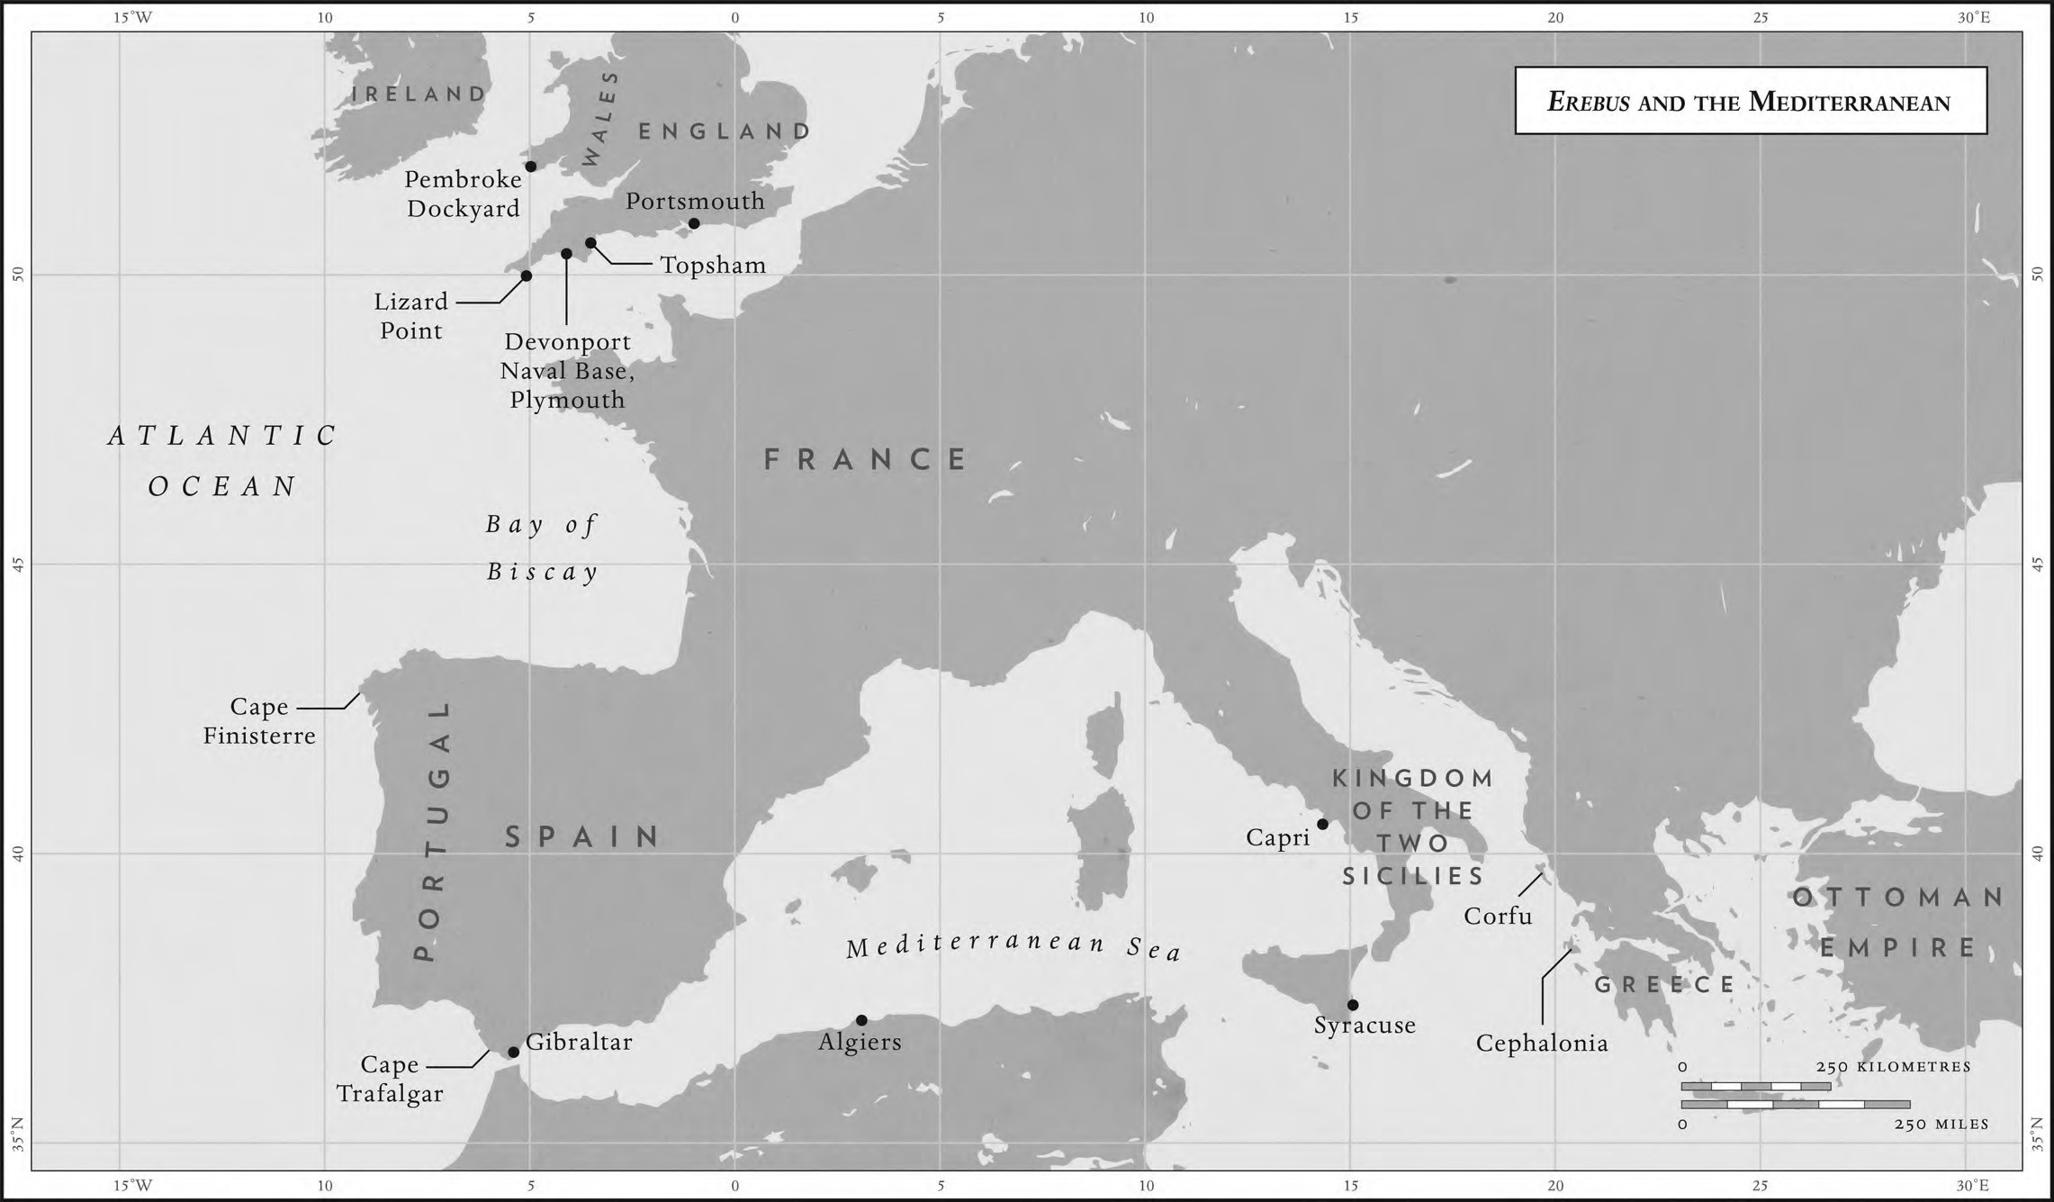
Laziness, or failing to jump to orders, was considered a serious breach of discipline, and Robinson would have been made an example of, in front of the entire crew. He would have had his shirt removed and been lashed by his wrists to a grating put up across a gangway. The boatswain would probably have administered the whipping, using the feared cat-o’-nine-tails, a whip with nine knotted flails that scratched like a cat.
懒惰，或违反命令，会被认为是一种严重的违法乱纪行为，Robinson当着全体船员的面被作为了一个典型。他的衬衫被脱下，遭到鞭打的同时手腕也会被绑在舷梯的横栅栏上。水手长很可能会用一种很可怕的九尾鞭来执行鞭刑，这种鞭子由九根带结的索组成，打在身上就像猫挠一样难受。
Some men took pride in surviving a flogging, preferring ten minutes of pain to ten days in prison below deck. Michael Lewis, author of The Navy in Transition 1814–1864, even suggests that ‘there was a certain art in being flogged . . . a fine marine in good practice would take four dozen with a calmness of demeanour which disassociated the operation of the lash from the idea of inflicting pain by way of punishment and warning, and connected it up in people’s mind with the ordinary and routine’. But change was in the air. Just a few years later, in 1846, following persistent efforts by the MP Joseph Hume, every flogging at sea had to be reported to the House of Commons. This had an immediate effect. More than 2,000 floggings were meted out in 1839; by 1848 this had been reduced to 719. Use of the cat-o’-ninetails was outlawed in the Navy in around 1880, though corporal punishment with the cane was administered until well after the Second World War.
有些人以经历过鞭笞而感到自豪，它们宁愿忍受十分钟的痛苦，也不愿被关在甲板下禁闭十天。《海军的转折1814-1864》（The Navy in Transition 1814-1864）一书的作者Michael Lewis甚至认为，“被鞭打是一种艺术……如果一名优秀的海军陆战队员近期表现出色，为了让他能保持不卑不亢，就会将他鞭打四十八下，这就将鞭打这一行为与通过施加痛苦来进行惩罚和警告的想法分开，使人们把它看作成一种常规和惯例。” 但时代在进步。仅仅几年后，也就是1846年，在议员Joseph Hume的不懈努力下，规定海上的每一次鞭打都必须上报给众议院(House of Commons)。这产生了立竿见影的效果。1839年，有超过2000人被鞭打；而到了1848年，这个数字就减少到了719。大约在1880年前后，海军开始明令禁止使用九尾鞭，因此直到第二次世界大战后很长一段时间，体罚的方式也一直主要是藤条。
Robinson’s whipping apart, time passed uneventfully, each day being a ritual of eating, sleeping, manning the decks and endless scrubbing and washing. The obsession with ‘scrubbed hammocks and washed clothes’ was, of course, more than a matter of cleanliness. It was a matter of routine, for without routine there was no discipline.
Robinson的体罚结束后，日子就变得平淡起来，每天都是诸如吃饭、睡觉、甲板警戒、无止尽的擦洗等日常安排。当然，之所以沉迷于“吊床和衣服的清洗”，不仅仅是简单的卫生问题。这虽然只是日常安排，但日常安排如果都做不好还谈什么纪律。
Occasionally something more interesting would happen. On 7 April 1828 the captain’s log reports a ship bound for New York from Trieste being boarded and searched. On 24 June, ‘1 Russian Line of Battle Ship and a Brig came in sight. 13 gun salutes were exchanged and a covered Jolly Boat took the captain across to what turned out to be a Russian Admiral’s flagship.’ On the same day the log notes: ‘Jolly Boat returned. Opened cask of wine, No 175. 24 and one-eighth gallons.’
偶尔也会发生一些有趣的事情。1828年4月7日，船长的航海日志描述道说，它们登船检查了一艘从里雅斯特驶往纽约的船。6月24日，它们遇到了一艘俄国战舰和一艘双桅帆船，他们互相回敬了13声礼炮，船长乘坐着一艘随船的带篷小艇前访，后来证实这是一位俄罗斯海军上将的战舰。同一天，航海日志上写着:“随船小艇回归，并带来了装满0.125加仑175.24号进口蒸馏酒的酒桶。”
Once Erebus was on station around Greece and the Ionian islands, the ‘Remarks at Sea’ read more and more like a holiday brochure. Endless days of ‘Light Breeze and Fine Weather’, and an itinerary to die for: Cephalonia, Corfu, Syracuse, Sicily and Capri. Erebus’s posting could hardly have been more idyllic. Unless you were Caleb Reynolds of the Marine Artillery, given twenty-four lashes for ‘uncleanliness and disobedience of order’; or Morris, Volunteer First Class, given ‘12 lashes over the breach for repeated neglect of duty and disobedience of orders’. Considering where she was, Erebus doesn’t sound to have been a happy ship.
每当厄瑞玻斯号停驻在希腊和爱奥尼亚群岛周围时，“航海日志”读起来就变得像一本度假手册。每天都是“微风和煦的好天气”，还有一段每个人都梦寐以求的旅程：洛尼亚岛、科孚岛、锡拉库扎、西西里岛和卡普里岛。厄瑞玻斯号的停驻地都是些悠闲度日的好去处。除非你是海军炮兵部队的Caleb Reynolds，因为“不讲卫生和违抗命令”而被鞭打了24下；或者是头等舱的志愿者Morris，因为“屡次玩忽职守和违抗命令”而被鞭打了12下。不过考虑到厄瑞玻斯号的身份地位，玩乐的事情似乎在这艘船上很少发生。
Things began to change as she entered her second year of duty in the Mediterranean, with the appointment of Commander Philip Broke. The son of Rear-Admiral Sir Philip Bowes Vere Broke, who made his name with the audacious capture of the USS Chesapeake in 1813, his approach seems to have been rather different from Haye’s. Certain rituals continued much as they had before – the log continues to record the mundane details of washing and cleaning and holystoning of the decks, the state of the provisions, wind directions and reefing of the sails – but the beatings appear to have declined. Broke had a different way of instilling discipline in the ship’s crew, or at least a different set of priorities for his ship. Weekly, and latterly almost daily, the log is now filled with artillery exercises. On 13 April 1829: ‘Exercised a division of seamen at the Great Guns, and Marine Artillery at small arms.’ On 20 April, off the island of Hydra: ‘Exercised a division of seamen with broadswords.’ On 6 May: ‘Exercised a division of seamen firing at a target with pistols.’ Whether it was just another way of dealing with the perennial problem of boredom or in response to some specific instruction from the Admiralty, Broke seemed more keen than his predecessor to see Erebus as a fighting machine. But he never had the chance to show what she could do, for by May 1830 Erebus was on her way home, having never fired a gun in anger.
在地中海上执行任务的第二年，随着Philip Broke被任命为指挥官，事情开始发生变化。作为海军少将Philip Bowes Vere Broke爵士——曾因俘获了美军军舰切萨皮克号而声名显赫——的儿子，他的行事方式似乎与Haye截然不同。某些固定程序一如既往地继续着——航海日志依然记录着诸如洗刷、清洁、磨甲板、补给状态、风向和收帆之类的琐碎小事——但鞭打的次数似乎减少了。Broke向船员灌输纪律的方式截然不同，或者至少在他的船上很多事情的轻重缓急有所不同。日志里每周都记录着炮兵演习，后来甚至演变成几乎每天都有。1829年4月13日：“进行了一个师的水手和携带轻武器的海军炮兵演习。”4月20日，在九头蛇岛附近，“进行了一个师的水手近身战演习。” 5月6日：“进行一个师的水手手枪射击演习。”Broke似乎比他的前任更热衷于把厄瑞玻斯号看作是一架战斗机器，这可能是他消磨打发无聊时间的一种方式，也可能是接到了海军部某些明确指示所采取的措施。不过他从来没有展示她的机会，因为直到1830年5月，厄瑞玻斯号都已经在回程的路上了，也没能真枪实弹的打一次。
Two rather heart-warming late entries follow: ‘Lowered a boat for the ship’s company to bathe’ and, on reaching Gibraltar on 27 May, ‘Hove to, to bathe.’ Bathing, rather than flogging, seemed to be more to the liking of the crew’s new captain.
随后有两条相当暖心的记录：“放船让船员们下去洗澡，”还有5月27日到达直布罗陀的时候，“顶风停船漂航，去洗澡。”看来这位新船长更喜欢洗澡，而不是鞭打。
Three weeks later Erebus was within sight of the Lizard Lighthouse. On 18 June her artillery and Great Guns were rolled out by Commander Broke for the last time, and on 26 June 1830 she reached Portsmouth, furling her sails and lowering her flags in respect for King George IV, who had died that morning. (Respect that was not afforded to him by his obituary in The Times: ‘There never was an individual less regretted by his fellow creatures than this deceased king. What eye has wept for him. What heart has heaved one throb of unmercenary sorrow.’) He was succeeded that day by his younger brother, who became William IV. William’s ten years in the Navy had earned him Nelson’s praise and the affectionate title of the ‘Sailor King’.
三周后，厄瑞玻斯号进入了蜥蜴灯塔的范围。6月18日，厄瑞玻斯号在Broke的指挥下最后一次发射大炮枪火，1830年6月26日，她到达了朴次茅斯后卷帆降旗，向那天早上去世的国王乔治四世致敬。(《泰晤士报》的讣告中曾对这位国王冷嘲热讽：“世上还没有人像这位国王一样，死时得不到人民的婉惜。试问这世上有谁会为他落泪呢？又有哪颗心为他悸动并进行真挚的哀悼呢？”) 那天，他的弟弟威廉四世接替了他的位置。威廉曾在海军服役十年，他还赢得过纳尔逊的赞扬和“水手之王”的亲切称号。
As the British Crown changed hands, Commander Broke and the crew of Erebus were paid off. Despite her captain’s best efforts at mustering his men to roll out the Great Guns and flash their broadswords, Erebus would never again be a warship.
随着英国的王位易手，指挥官Broke和厄瑞玻斯号的船员们也最终功成身退。尽管埃里伯斯的船长曾经很努力地召集他的士兵们发射大炮，磨练近战，但厄瑞玻斯号再也不会是一艘战舰了。

