chapter 17

THE INUIT STORY
Good Friday, 21 April 1848 was the last night the expedition was known to have spent aboard the ship. Article 11 of the Admiralty’s instructions, ‘The two ships are on no account to separate’, had been obeyed to the letter. Erebus and Terror had stayed together to the end. Now they were left to drift in the ice, empty and deserted, at the mercy of the elements.
1848年4月21日，耶稣受难日，那是远征队在船上度过的最后一个夜晚。他们一直遵守着海军部的第11条指令——“两艘船不得分开”。所以厄瑞玻斯号和恐怖号直到最后都一直相伴左右。现在，她们都被抛弃在冰面上漂流，船上空无一人，任凭大自然的摆布。
Or perhaps not. Research, based on close examination of oral Inuit testimony, backs up a different scenario. John Rae had shown the importance of listening to the Inuit – indeed, that was how he learned the first news of the expedition’s fate. Much more information was gathered by two kabloonas who came after him, and who, like Rae, lived closely with the Inuit and learned their language.
也或者不是这样的。随着一项针对因纽特人口述证词的仔细的审查研究，另一种可能性逐渐浮出水面。John Rae证明了倾听因纽特人意见的重要性——事实上，他也正因如此才成为第一位得知了探险队的相关命运的人。在他之后，有两名开布鲁纳人（kabloonas，主要指混迹在北极的白种人）收集了更多的信息，他们和Rae一样，和因纽特人密切接触，并学习了他们的语言。
One was Charles Francis Hall, who believed God was calling him to find remaining members of the Franklin expedition who, he was sure, were still alive and living with the native people. An American of the frontier kind, Hall had been at times a blacksmith, an engraver and a publisher. In 1860 he hitched a ride on an American whaler, which set him down on Baffin Island. He found no Frankliniana, but stayed for two years and made lifelong friendships with two natives, Too-koo-li-too (Taqulittuq) and Ebierbing (Ipivik). It wasn’t until 1869, during a second Arctic voyage, that he reached the holy grail of Franklin-hunters, King William Island. His Inuit hosts were not keen to spend time trawling Franklin sites on the island. There was poor hunting there and they needed to get on with their own lives. Feeling frustrated, Hall never got to all the sites, but he amassed a wealth of stories from his hosts, which provided the groundwork for some very interesting conjectures.
其中一位是Charles Francis Hall，他相信寻找富兰克林远征队的剩余成员是上帝对他的指引，他一直坚信他们有些人还活着，并和本地人生活在一起。Hall是拓荒时代的美国人，也曾做过铁匠、雕刻家和出版商。1860年，他搭乘着一艘美国捕鲸船来到了巴芬岛。他一直找不到Franklin等人，但在那里呆了两年后，他和两名本地人——Too-koo-li-too (Taqulittuq) 和Ebierbing (Ipivik)——结下了深厚的友谊。直到1869年的第二次北极航行中，他才到达了威廉国王岛——那个属于富兰克林的寻找者们的圣地。接待他的因纽特人不太愿意花时间寻找Franklin团队在岛上的落脚点。而且那里很难狩到猎物，他们还需要过自己的日子。对此感到沮丧的Hall最终还是没能探索完所有的地点，但他从因纽特人那里获悉了丰富的故事，这为一些非常有趣的猜想提供了基础。
These were added to in 1878 by another American, Lieutenant Frederick Schwatka of the US Army. He led an investigative expedition, not as a result of divine guidance this time, but through the sponsorship of the American Geographical Society. After spending a summer combing King William Island and the Adelaide Peninsula, and working closely with the Inuit, he was able to corroborate many of the stories that had been told to Rae and Hall. Schwatka it was who discovered, among many other relics, a skeleton that proved to be that of Lieutenant John Irving. It was one of only two bodies from the Franklin expedition to be repatriated, and now lies buried in Dean Cemetery in Edinburgh.
1878年，另一位美国人，美国陆军中尉Frederick Schwatka也加入了搜寻的行列。他率队进行了一次调查考察，这一次不是在上帝的指引下，而是在美国地理学会的赞助支持下。他与因纽特人进行了密切合作，并在威廉国王岛和阿德莱德半岛进行了一个夏天时间的仔细梳理，最终Rae和Hall许多被告知的故事得到了证实。Schwatka发现了许多遗物，其中一具骨骼，后来被证明是John Irving中尉的。这是富兰克林探险队被运回的仅有的两具尸体的其中之一，现在埋葬在爱丁堡的迪恩公墓。
David C. Woodman, in his 1991 book Unravelling the Franklin Mystery, drew on all these records to compile an alternative account of the last days of the ships and crew. It is not definitive – no account of the Franklin expedition ever can be – but it is thought-provoking. As he concludes: ‘For one hundred and forty years the account of the tragedy given to Rae by In-nook-poo-zhe-jook and See-u-ti-chu has been accepted and endorsed . . . it was a remarkably accurate recital of events. But it was not the whole story.’
David C. Woodman在他1991年出版的《解开Franklin之谜》一书中，基于所有的已知记录，对船只和船员最后日子进行了另一番描述。这本书的描述并不是最终结论——没有任何关于Franklin远征的记载能做到这一点——但它却是发人深省的。正如他所总结的那样：“140年以来，In-nook-poo-zhe-jook和See-u-ti-chu对Rae所讲述的悲剧故事已经得到了广泛的接受和认可……这些对事件的描述是准确的。但这不是故事的全部。”
Central to Inuit testimony, gathered by Schwatka and Hall, is that they first saw Erebus and Terror in late 1848, or even 1849, after the ships had been apparently abandoned. Not only that, but all their accounts agreed that the ships were manned at the time: there was activity aboard, and indeed some of the Inuit went onto the ships and talked with the crew. Yet the Victory Point note states clearly that all the remaining members of the expedition left the ships on 22 April 1848 to head south. There is no reason, however, to assume that they all stayed together. Some clearly struggled as far the mainland, finally perishing at a place that Schwatka christened ‘Starvation Cove’, but if the Inuit had seen men on the ships as late as 1849, then it would suggest that at least some others might have returned.
Schwatka和Hall收集到的因纽特人证词的主要内容是，他们第一次看到厄瑞玻斯号和恐怖号是在1848年末，甚至是在船只被遗弃后的1849年。不仅如此，他们所有的描述都一致认为：当时船只上有人，并且确实有一些因纽特人上了船与船员们进行交谈。然而，胜利角笔记清楚地指出，当时所有幸存的探险队成员都在1848年4月22日离开船只向南进发。然而，我们不应该假设他们一致都在一起。有些人显然挣扎着来到了遥远的大陆，最终在一处被Schwatka命名为“饥饿湾”的地方死去，但如果1849年因纽特人还在船上看到过人的话，那么这表明至少还有一些人可能已经回来了。
Woodman found a powerful piece of evidence for the idea that there had been a return to the ships. This was the discovery, by Lieutenant Schwatka, of a grave at Victory Point, identified by a medal in the shreds of uniform clinging to the bones as that of Lieutenant Irving of the Terror. The grave was properly dug and had heavy boulders around it. It must have been excavated by a party of fit men. But when? Irving was alive and well when he was mentioned in the Victory Point note, so he cannot have died before they left in April 1848. The discovery of his grave is proof for Woodman that Irving, and presumably others, came back and reoccupied at least one of the ships, bearing out the repeated Inuit accounts of meeting white men on the north-east part of King William Island long after they were supposed to have departed. It led Woodman to back up the theory that the party of 105 didn’t actually get very far before they split, some going on south to find animals to hunt, some heading east in search of Hudson’s Bay Company depots, and others returning to the ship.
Woodman发现了一个强有力的证据，证明曾经有人回到了船上。那就是Schwatka中尉在胜利角发现的一座坟墓，从挂在骨头上的军服碎片上的一枚奖章可以看出，那是恐怖号上的Irving中尉。坟墓挖得很得体，周围还有一些沉重的石头。这座墓一定是被一群健壮的男人挖出来的。但是什么时候呢？在胜利角笔记中提到Irving的时候他还活着，所以他不可能在1848年4月他们离开之前就去世了。这座坟墓的发现为Woodman提供了证据，证明Irving，可能还有其他人回来了，并至少重新占领了一艘船，这也证实了因纽特人反复讲述的在威廉国王岛东北部遇见白人的故事，而那时候他们应该已经离开很久了。这使得Woodman确信这一观点，即105人的队伍实际上并没有走多远就分开了，一部分人向南寻找动物狩猎，一部分人向东去寻找哈德逊湾公司的仓库，还有一部分人则回到了船上。
Taking all this information, rumour and folk tale together, it looks as if the most likely scenario of the last days of the men and ships of the Franklin expedition goes something like this. In April 1848, ten months after Franklin’s death, Crozier and Fitzjames lead the remaining men, with three sledges, some 15 miles across the ice to Victory Point. Here Lieutenant Irving is deputed to go to the cairn a few miles away and fetch one of the two ‘All well’ notes left eleven months earlier by Gore and Des Voeux. The note’s cheerful message is amended by Fitzjames, in the light of the grim events of the last winter. Crozier counter-signs it, in a slightly weaker hand, adding that they are leaving the next day for Back’s Fish River. They leave a lot of material at Victory Point, presumably to lighten the load. This would account for the piles of blankets and ropes found by Hobson. They must have made 50 miles down the coast before they stopped, leaving the boat behind, probably as shelter and to further lighten the load. This is where the party first split, with those still fit enough taking some of the provisions and continuing south, possibly splitting again as they headed for Back’s Fish River. The others, maybe because they had scurvy so badly they were unable to move, stayed behind, whilst others may have been well enough to stagger back to the ship.
把所有这些情报、传言和民间故事结合起来，看起来Franklin远征队的成员和船只在最后的日子里最有可能发生的情况是这样的。1848年4月，也就是Franklin去世10个月后，Crozier和Fitzjames带领剩下的人，拉着三辆雪橇，穿越了大约15英里的冰面到达胜利角。在这里Irving中尉奉命到几英里外的石堆去取十一个月前Gore和Des Voeux留下的两张“一切顺利”的字条中的一张。根据去年冬天发生种种可怕事件，Fitzjames修正了这封言辞愉悦的信。Crozier用略有无力的手签下了这份合同，并补充说他们将在第二天前往背鱼河。他们在胜利角留下了很多材料，大概是为了减轻负担。这就能解释为什么Hobson发现了一堆毯子和绳子。他们一定沿着海岸走了50英里才停下来，把船留在后面，可能是为了避风，减轻负担。这是探险队第一次分散开的位置，那些身体还不错的探险队成员带着一些补给继续南下，而他们可能在前往背鱼河的过程中再次分散出一部分人。有一部人可能是由于严重的坏血病，难以移动，留在原地，而其他人可能身体还撑得住，便蹒跚着返回了船上。
A line of skeletons marks the progress south. One found east of Cape Herschel is probably that of Thomas Armitage, who had Peglar’s notebook beside him where he fell. Another body, believed at the time to be Henry Le Vesconte, was recovered by Hall and was later returned to England. Two skeletons were found by the Amundsen expedition in 1904. That the last survivors crossed the Strait, discovering the Northwest Passage as they went, is borne out by the findings of several bodies on the mainland, at Starvation Cove, only a few miles from the Back’s Fish River. This was the end of the road for the southern party.
一路的尸骸标明了他们向南行进的过程。在赫歇尔角以东发现的一具尸体，可能是Thomas Armitage的，他摔倒时身边还放着Peglar的笔记本。另一具尸体被Hall发现，当时被认为是Henry Le Vesconte，随后被运回英国。1904年，Amundsen探险队发现了两具骨架。最后的幸存者穿过海峡，在他们前进的过程中发现了西北通道，在大陆上的饥饿湾发现的几具尸体证实了这一点，那里离背鱼河只有几英里。这是向南方前进的那批人的终途。
The handful of men who, if Inuit testimony is right, had remained on King William Island and were seen back at the ship almost certainly survived a fourth winter, before leaving the ships – again described in Inuit testimony – to shoot caribou, but never returning.
如果因纽特人的证词是正确的，那几个留在威廉国王岛的人被看到回到了船上，几乎可以肯定的是他们熬过了第四个冬天，然后离开了船——根据因纽特人的证词描述——去射杀驯鹿，但再也没有回来。
There is no evidence to suggest that by the end of 1850 any of the 129 men of the Franklin expedition were left alive. Which means that, of all the rescue operations sent out, only the very earliest would have stood any chance of finding them alive.
没有证据表明，到1850年底，Franklin远征队的129名探险者中还有人活着。这意味着，在所有派出的救援行动中，只有最早的那次才有机会拯救他们。
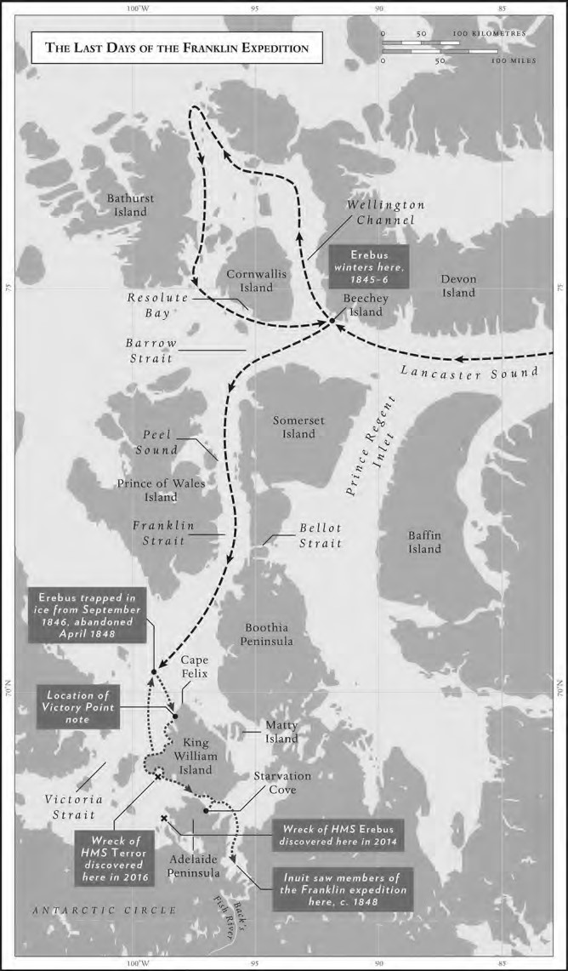
Penguin
Random
House
What of Erebus and Terror? The presence of a ship, or ships, had been a consistent part of Inuit stories; there is recurring and fascinating mention of men on a seal hunt seeing a ship at a place called Utjulik, ‘place of bearded seals’, some way south of King William Island. The Inuit boarded it and later told Charles Hall that they had found it deserted, save for the body of a very large white man lying on the floor: ‘there was flesh about this dead man, that is, his remains quite perfect – it took 5 men to lift him. The place smelt very bad.’ They gave enough detail about the interior of the ship, and the sort of things they found on board, to identify it as either Erebus or Terror.
那厄瑞玻斯号和恐怖号呢？她们，或者说她一直出现在因纽特人故事中；书中反复提到，在威廉国王岛以南的某个地方，人们在一个叫Utjulik的地方看到了一艘船，那是一处“髯海豹聚集地”。 因纽特人曾登上船，后来告诉Charles Hall，他们发现船上空无一人，只有一具身材高大的白人尸体躺在地板上：“这个死人肉体完整，也就是说，他的遗体保存完好——需要5个人才能把他抬起来。船上的味道很难闻。”他们详细描述了船只内部的情况，以及他们在船上发现的东西，可以确定的她是厄瑞玻斯号或者恐怖号。
A strange twist to the story was the sighting of two ships looking very much like Erebus and Terror, on an iceberg off Newfoundland in 1851. They were seen from a passing ship, the Renovation, but no attempt was made to approach them. In the 1920s Commander Rupert Gould, who liked what he called ‘Unexplained Facts’, looked carefully at the Admiralty’s report on the sighting and, far from dismissing it, came up with some intriguing findings. The two ships were very similar in appearance to Erebus and Terror, both flush-decked and one slightly bigger than the other. They were close together on floating ice, so they must have come from somewhere in the Arctic, and they appeared to have been carefully dismantled. Neither was a whaler, and both were deserted. Gould studied the currents in the Arctic and found that there were counter-currents running west to east, which could quite plausibly have carried the abandoned ships out into the Atlantic. From what we know from recent discoveries, they could not have been Franklin’s ships, but in that case what were they?
故事的发展在1851年那年出现了一个奇怪的转折点，有人看到了两艘看起来非常像厄瑞玻斯号和恐怖号的船只在纽芬兰附近的一座冰山上。一艘经过的船只革新号发现了她们，但是没有人试图接近她们。在20世纪20年代，指挥官Rupert Gould热衷那些他所谓的“难以解释的事实”，他仔细研究了海军部关于目击事件的报告，并没有完全否定它，而是得出了一些有趣的发现。这两艘船在外观上与厄瑞玻斯号和恐怖号非常相似，都有平坦的甲板，一艘比另一艘稍微大一些。它们在浮冰上靠得很近，所以它们一定来自北极的某个地方，而且它们似乎是被仔细地拆解过。两艘船都不是捕鲸船，而且都被遗弃了。Gould通过研究了北极的洋流，发现有一股由西向东的逆流，而很有可能就是这股逆流把废弃的船只带到了大西洋。根据最近的研究来看，她们不可能是Franklin的船，那么她们又是谁的呢？
Both Erebus and Terror probably disappeared soon after their crews. Very little of the fabric of the ships, or their contents, was found in Inuit communities. If they had remained afloat for long they would have been stripped, but the likes of Hall and Schwatka found no evidence of this. That they didn’t stay above water for long chimes with Inuit stories of one ship sinking after being crushed in the ice, and the other, probably Erebus, having been holed by mistake as the natives were prizing out firewood, and sinking in water so shallow that the tips of her masts were showing above the water.
厄瑞玻斯号和恐怖号在他们的船员消失后不久变得不知去向。在因纽特人族群间，几乎没有发现船只的布料或其他相关的物品。如果她们长时间在海上漂浮的话，她们肯定会被拆的七零八落，但Hall和Schwatka等人均没有发现任何相关的证据。她们没有长期保持在水面上，这与因纽特人的故事相吻合，根据他们所说其中一艘船被冰层压碎后沉没,而另一艘很可能是厄瑞玻斯号的船，则由于本地人撬木头当柴火的时候失误出现了漏洞，导致她在一处浅水区沉没，以至于桅杆的顶部仍露出在水面之上。
The whole relationship with the Inuit remains a mystery. King William Island did not offer much hunting, but there was enough game to attract parties of Inuit, and in the almost two years they were trapped in the ice, it seems odd if no one aboard Erebus and Terror sought Inuit help, to trade food and glean any information as to where they were and how they might get out. Arctic explorers like Parry and James Ross had set an example in engaging with the local people. We know that some of the officers on Erebus were compiling an Inuit phrasebook in Disko Bay, so the intention to make use of any contact with them must have been there. Why then, when they took to the ice in 1848, did they seem so unprepared? Could it be that Franklin, who had been criticised by some after his disastrous Coppermine River expedition of 1819–22 for sticking too closely to Navy orders, still lacked the flexibility of outlook that would have encouraged him to make the most of Inuit expertise?
他们与因纽特人的关系至今仍是个未解之谜。虽然威廉王岛没有太多的猎物，但依然足以吸引各方的因纽特人前来狩猎，在他们被困在冰层中的近两年时间里，如果说厄瑞玻斯号和恐怖号上没有人去寻求因纽特人的帮助是非常奇怪的事情，他们可以交换食物并收集情报，了解所处的位置以及如何进行脱困。像Parry和James Ross这样的北极探险家在与当地人打交道方面树立了榜样。我们还知道，厄瑞玻斯号上的一些军官在迪斯科湾曾编纂了一本有关因纽特人常用语的手册，所以他们一定曾试图与因纽特人进行接触。那么，当1848年他们走上冰面时，为什么看起来是如此毫无准备呢？Franklin在1819年至1822年的科珀曼河探险中曾因死板地遵守海军命令而遭到过一些人的批评，他是否仍然缺乏灵活性，而导致他没能充分利用因纽特人的专业知识呢?
Tragically, it appears that by the time it was needed, most of the opportunity for local contact had been neglected for too long. The expedition had congratulated itself on being so well provisioned and so well equipped, and yet, where it really mattered, there was a fatal weakness. They thought they had everything they required, and seem to have continued to believe that until it was too late. When they left their wooden fortresses and exposed themselves to the land, what they needed most of all was local intelligence. But by then they were already dying. The Inuit must have known that. The state of the men must have alarmed them, but probably also repelled them. The time for both sides to help each other had passed.
不幸的是，大部分与本地人接触的机会都长期被他们忽视，直到他们真正需要的时候。探险队曾庆幸自己有这么如此精良的食物和装备，然而却在真正关键的地方留下了一个致命的弱点。他们认为自己已经拥有了所需要的一切，而且直到最后才幡然悔悟，但是已经为时已晚了。当他们离开木制堡垒，暴露在这片土地上的时候，他们最需要的就是当地的情报。但那时他们已经奄奄一息了。因纽特人肯定也意识到了这一点。这些男人的状态一定让他们感到震惊，但也可能让他们感到排斥。双方互相帮助的时机已经过去了。
At a celebration dinner of the American Geographical Society in October 1880, Lieutenant Schwatka told his audience that he considered that the destruction of any significant Franklin records had been established beyond reasonable doubt, and in his book The Long Arctic Search he concluded that the ‘Franklin problem’ had been settled ‘in all its important aspects’. The Secretary of the Royal Geographical Society in London seemed to endorse his view. Writing in praise of Schwatka’s journey ‘without parallel’, Sir Clements Markham paid tribute on behalf of his fellow Englishmen, who would ‘always cherish a feeling of gratitude for the kindly deed of the brave Americans, who tenderly collected and buried some of the bones of our heroes – a task which, we well know, entailed no small amount of peril and hardship’.
在1880年10月美国地理学会的庆祝晚宴上，Schwatka中尉告诉众人,他认为有关Franklin的相关重要记录被销毁已经是毋庸置疑的事情了，并在他的著作《漫长的北极搜索》一书中得出结论，“Franklin的问题”在“各种关键的地方”都已经得到了解答。伦敦皇家地理学会的秘书似乎也赞同他的观点。Clements Markham爵士也认为Schwatka的航程是“举世无双的壮举”，他代表他的英国同胞向他表示敬意，他们将“永远感激这些勇敢的美国人的善举，他们温柔地收集并埋葬了我们英雄的部分遗骨——而我们也很清楚，这项任务需要面对很大的风险和艰辛”。
The indignation that fuelled the search, the wounded national pride that gave it such an imperative, and the appetite of newspapers, publishers and their readers for the grisly details had all diminished. There was a palpable sense of closure. Thirty-five years after Franklin’s expedition set out, the search for explanations had been as fruitless as the search for survivors.
面对着受伤的民族自豪感，这起愤慨激起的搜寻行动显得如此地势在必行，然而报纸、出版商和读者们都对那些恐怖的细节逐渐失去了兴趣。这也让人觉得，似乎一切都快结束了。在Franklin探险队出发35年后，人们一直在努力寻找的原因，就像一直在努力寻找的幸存者一样，终究是一场空。
One thing that remained undiminished was Jane Franklin’s energy. She may have reluctantly accepted the loss of her husband, but in a way it was easier for her to work on his reputation with him gone. The unpleasantness in Van Diemen’s Land had lost its sting. The murky allegations of cannibalism had been tastefully set aside. The suggestion that her husband had been too old or too unfit to lead the expedition had been subsumed by his fate. Her task now was to enshrine his reputation in something more permanent. His body might never be found, but she would make his likeness live for ever in stone and bronze. With the help of some powerful friends, she successfully lobbied Parliament to vote a £2,000 contribution towards a statue of Sir John. It was unveiled in 1866 on Waterloo Place in London, beside the elegant façade of the Athenaeum Club, of which Franklin had been a founder member. The sculptor, Matthew Noble, has Sir John standing tall and defiant with the single word ‘Franklin’ incised below him. In the words of a modern commentator, Robert Douglas-Fairhurst: ‘In life a podgy, balding man of middling height, in death he was transformed into a firm-jawed figure eight feet tall, perched on an imposing granite plinth.’
但还有一样东西没有减弱，那就是Jane Franklin的活力。她也许不情愿地接受了丈夫就这样离去，但从某种程度上说，丈夫离去使得她更容易挽回他的声誉。范迪门斯之地发生的不愉快已经变得无足轻重。关于同类相食的可疑指控已被雅致地搁置一旁。她丈夫年纪太大以及不适合领导这次探险的说法，已经因为他的命运而被接纳。而她现在的任务是把他的名声刻在一些更长久的东西上。他的尸体也许永远不会被发现，但她会让他的形象永存在石头和青铜之上。在一些有权有势的朋友帮助下，她成功地游说议会投票同意为John爵士的雕像捐赠2000英镑。这座雕像于1866年在伦敦滑铁卢广场揭幕，就在雅典娜俱乐部（Franklin是该俱乐部创始人之一）优雅的外墙旁边。雕塑家Matthew Noble将John爵士刻画得昂首挺胸，而在他的下方刻着“Franklin”一词。用现代评论家Robert Douglas-Fairhurst的话来说：“活着的时候，他是一个矮胖、秃顶、中等身材的男人，死后，他变成了一个八英尺高的坚毅形象，置身在一块威风的花岗岩底座之上。”
A relief panel depicts his burial in the ice, his coffin, half-draped with a flag, mourners standing on either side. This is the sculptor’s imagination at work, as the place and indeed the cause of Franklin’s death remain an unsolved mystery. In an inscription on the marble plinth below, Franklin’s rehabilitation is complete. The Man Who Ate His Boots becomes ‘The Great Arctic Navigator’ who ‘with his brave companions . . . sacrificed their lives to complete the discovery of the North West Passage’.
浮雕描绘了他被埋葬在冰天雪地里的情景，他的棺材半掩着一面旗帜，两边都站着哀悼者。这来源于雕塑家的想象，因为Franklin的死亡地点和死因仍然是一个未解之谜。在下方大理石底座上的有关Franklin铭文也已经复原完成。吃了自己靴子的人成为“伟大的北极航海家”，他“和他勇敢的同伴……他们牺牲了自己的生命，成功发现了西北航道”。
This latter claim was never positively established, but Lady Jane defended it with the ferocity of a mother on a nest. She vigorously attacked Robert McClure for his, proven, claim to have been the first to discover the Passage, albeit by sledge and boat, in 1853–4. She was said to have been infuriated by the inscription on the Franklin statue in Hobart, Tasmania, which had the temerity to claim that Sir John had ‘lost his life trying to find the North West Passage’. He did not just try, he succeeded, was her indignant response.
后一种说法从未被证实，但Jane夫人用母亲护巢时的那种凶狠为其辩护。她猛烈抨击了Robert McClure，因为他声称自己是第一个在1853-1854年发现这条通道的人，尽管是通过雪橇和船发现的。据说，她还对塔斯马尼亚州霍巴特镇的Franklin雕像上的铭文感到恼火，这尊雕像轻率地声称约翰爵士是“为了寻找西北通道而牺牲的”。她愤怒地回答说，他不只是尝试，他成功了。
The finest memorial, in my opinion, although it is dedicated only to the memory of the officers, is a marble relief carved by Richard Westmacott that stands at the entrance to the chapel of the Royal Naval College in Greenwich. On either side of it are two figures, in profile. One represents hope and the other despair. Lady Franklin didn’t much care for this less-than-triumphant embodiment of the grim realities of the expedition. As Andrew Lambert, Franklin’s bio grapher, writes, ‘it fell far short of the heroic image Jane required’. It stands above the resting place of one of only two members of the expedition whose bodies were identified and returned to England. A marble plaque reads: ‘Beneath lie the remains of one of Franklin’s companions who perished in the Arctic Regions.’ These bones, retrieved by Charles Hall, were for a long time assumed to be those of Lieutenant Le Vesconte, but have now been established almost certainly as those of Harry Goodsir, the assistant surgeon on Erebus. For a long time this evocative memorial, probably considered a bit morbid at the time, was hidden away behind the altar of the chapel.
在我看来，最好的纪念碑是矗立在格林威治皇家海军学院教堂入口处由Richard Westmacott雕刻的大理石浮雕，虽然这处浮雕只是为了纪念军官们。浮雕的两边各有两个侧面的人物。一个代表希望，另一个代表绝望。Franklin夫人不太喜欢这个算不上胜利反而体现远征残酷现实的作品。正如Franklin传记作者Andrew Lambert所写的那样，“它远没有达到Jane所要求的英雄形象”。 探险队中仅有的两具遗体被确认并运回英国，而这处浮雕就矗立其中一处的安息地之上。一块大理石牌匾上写着：“下面躺着Franklin的一位同伴的遗体，他在北极地区遇难。”这些尸骸是Charles Hall找到的，很长一段时间都被误认为是Le Vesconte中尉的，但现在几乎可以确定是Harry Goodsir的，也就是厄瑞玻斯号的助理外科医生。可能是因为在当时被认为有点病态，在此后的很长一段时间里，这个引入深思的纪念碑一直都被隐藏在教堂的祭坛后面。
By the beginning of the 1880s most of the main players in the great Northwest Passage mission were gone. Not just Franklin and Crozier, but John Barrow, who died in 1848, around the same time as the leaders of his much-vaunted expedition were dying in the ice. Francis Beaufort, Edward Parry and both Sir John and Sir James Ross had been dead for almost twenty years. Of the old guard, only Edward Sabine was still alive. He was ninety-two, the sole survivor of that golden era of exploration that began in the wake of Waterloo.
到19世纪80年代初的时候，大部分西北通道任务的主要参与者都已经相继离世了。不只是Franklin和Crozier，还有John Barrow，他死于1848年，去世时间和他那支烜赫一时的探险队的领袖们死在冰面上的时间差不多。Francis Beaufort、Edward Parry以及John爵士和James Ross爵士都已经去世快20年了。在那群老将里，只有Edward Sabine还活着。他享年92岁，是当时滑铁卢战争后开始的黄金探险时代的唯一幸存者。
The febrile atmosphere that had surrounded the search and its dreadful findings had subsided by now. Instead of the horrors, so graphically captured by Landseer, there was instead a weary resignation, laced more with nostalgia than anger. In 1874 the new mood was captured by John Everett Millais in his painting ‘North West Passage’. An old sea captain with a sad and faraway look in his eyes sits at his desk, on which a map lies open. His daughter rests her hand on his as she sits on the floor, leaning up against him, reading a ship’s log book. This was the late-Victorian image of the Franklin expedition. A little sentimental perhaps, but conveying a sense of haunting sadness – the loss of a dream. But for the energetic Lady Franklin, the confirmation of her husband’s death consolidated her status as never before. She was now an international celebrity, universally admired for her persistence, loyalty and dedication. Despite the money she’d spent on the search, she was able to lease a grand house in Kensington Gore, the same road in London on which the Royal Geographical Society was later to set up its headquarters. Here she lived in some style, networking vigorously, giving dinner parties, keeping an eye on the wording of tributes and memorials and on the factual accuracy of the succession of books about the expedition. In his death, as in his life, she continued to manage her husband.
伴随搜索和种种可怕发现所引发的狂热气氛现在已经得到逐渐平息。那些Landseer生动描绘所引发的惊恐已经不在，取而代之的是一种带有疲倦的认命，其中蕴含着的更多是怀旧而不是愤怒。1874年，John Everett Millais在他的画作《西北通道》中流露出了这种新情绪。一位老船长坐在他的办公桌前，眼里忧伤而恍惚，桌上有张摊开的地图。他的女儿坐在地板上，靠在他身旁读着航海日志，并将手放在了他的手上。这是维多利亚时代晚期Franklin远征队的照片。这么说也许有点伤感，但作品确实传达出一种挥之不去的悲伤——那种失去梦想的遗憾。但对于精力充沛的Franklin夫人来说，她丈夫的死讯巩固了她前所未有的地位。她现在是一个国际名人，她的坚持，忠诚和奉献受到了普遍的赞扬。尽管她在寻找工作上花费了很多钱，但她还是在肯辛顿戈尔租了一套豪华的房子，皇家地理学会后来也在这条伦敦的街道上设立了总部。她在这里过着一种时髦的生活，积极与人社交，举办晚宴，密切关注颂词和纪念活动的措辞，以及有关这次探险的书籍的准确性。在他死后，就像在他生前一样，她继续管理着她的丈夫。
On 18 July 1875, at the age of eighty-three, Jane Franklin, in many ways the central figure in this otherwise all-male drama, finally ran out of steam. She died refusing to the last to take the medicine in which she never had much faith. The obituaries were sententious: ‘our regrets will be softened by the reflection that death may reveal to her what remains of that Arctic mystery which was the problem and purpose of her life,’ read one. But nothing would have delighted her more than to know that Francis McClintock, Richard Collinson and Erasmus Ommanney had been amongst those who carried her coffin at the funeral, and that Joseph Hooker and William Hobson had been there to pay tribute.
在1875年7月18日，83岁的Jane Franklin成为原本这部本来全都是男性的戏剧的中心人物，但最终还是耗尽了精力。她至死都拒绝服用那些她不报以信任的药物。其中一则讣告写道：“北极之谜是伴随她一生的问题和目的，而她的逝去也许会让她知晓真相，想到这一点，我们内心的遗憾也得以舒缓。”但是，如果她知道Francis McClintock、Richard Collinson和Erasmus Ommanney在葬礼上抬着她的灵柩，Joseph Hooker和William Hobson也到场致敬，那她肯定会非常高兴的。
A fortnight after her death the final unequivocal triumph of her campaign for the glorification of her husband came with the unveiling of his bust in Westminster Abbey. It stands just inside the west door, in an alabaster niche. McClintock has a memorial plaque below.
在她去世两周后，她丈夫的半身像在威斯敏斯特教堂揭幕，这是她为赞美丈夫取得的最后一次明确胜利。半身像就在西门内一处汉白玉壁龛里。下面是McClintock所写的追悼牌。
Dr John Rae, the bearer of bad tidings, has a stone on the floor.
The memorial bears an inscription written by the man who married Franklin’s niece, Alfred Lord Tennyson:
John Rae医生，这个坏消息的传递者，在地板上放了块石头。
纪念碑上镌刻着Franklin侄女Alfred Lord Tennyson的题词:
Not here: the white north has thy bones; and thou,
Heroic sailor­soul,
Art passing on thine happier voyage now,
Toward no earthly pole.
别处:白茫茫的北方有你的尸骸;还有你,
以及那英勇的航海者之魂,
你现将踏上更幸福的旅程，
朝着远离尘世极地的方向。
These few lines epitomise the mixed-up emotions that made Franklin such an exemplar of the Victorian spirit. The affirmation of a sacrifice that could never be judged on earth, but only in heaven. A sacrifice that rose above failure to touch the sublime. Something that united a nation in grief, but in that grief was glory.
这几行字浓缩了各种复杂的情感，而正是这种情感使得Franklin成为维多利亚时代的精神典范。这是一种永不该在人间而只能在天堂被审判的牺牲。一种超越失败而触及某种崇高境界的牺牲。它在悲痛中将整个国家团结在一起，在悲痛中蕴含着荣光。
The same sentiments would surface again to exalt another heroic failure, Robert Falcon Scott, whose death on the way back from the South Pole in 1912 provoked a similar national trauma. And, a few years later still, on the battlefields of France: Dulce et decorum est pro patria mori.
1912年，同样的情绪也在另一起英雄的失败中浮现，当时Robert Falcon Scott在从南极返程的途中去世，这也引发了类似的国家创伤。还有一次是发生在几年后的法国战场上：为国捐躯是美好且正确的（Dulce et decorum est pro patria mori，此句曾经常出现在阵亡战士的纪念碑上，后常用于谴责战争）。
In Waterloo Place in London, across the road from where the first Franklin statue stands, is a memorial to Captain Scott. His failure was to be beaten to the South Pole. Franklin’s was to be beaten to the first sea crossing of the Northwest Passage. The man who beat Scott to the Pole was Roald Amundsen. The first man to cross the Northwest Pas- sage by sea was Roald Amundsen. He has no memorial in London.
在伦敦的滑铁卢广场，第一尊Franklin雕像的对面，是一座纪念Scott船长的纪念碑。他曾经寻找南极点失败。而Franklin则在第一次横渡西北航道时失败了。击败Scott发现极点的人是Roald Amundsen。第一个从海上横渡西北航道的人也是Roald Amundsen。但他在伦敦没有纪念碑。

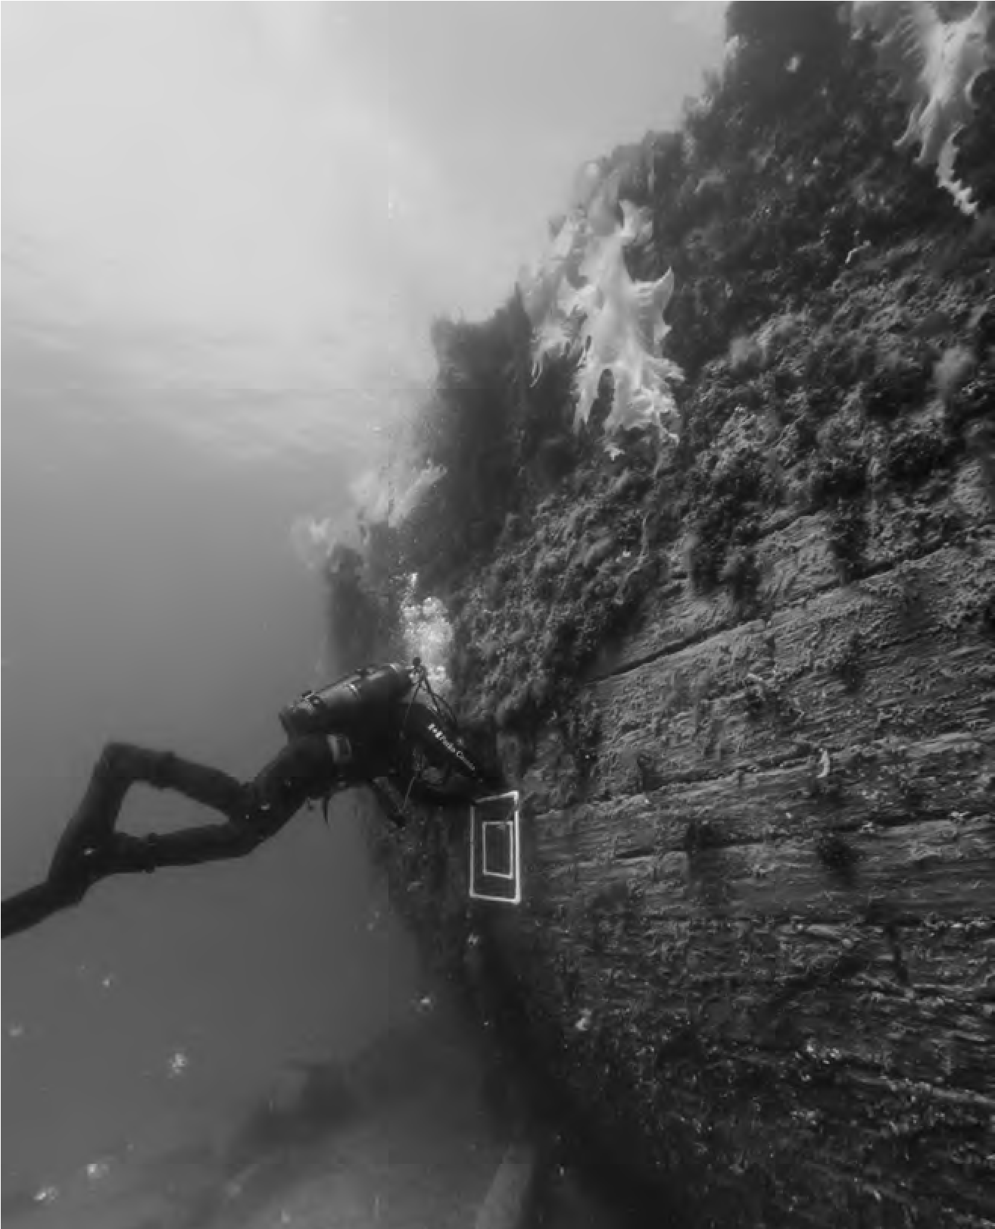
The first dive on the newly rediscovered
Erebus
.
Penguin
Random
House
针对新近发现的厄瑞玻斯号的首次潜水

